Français 2 Unité 4
Le Projet Final
OBJECTIVE:
You are working for your favorite clothing store and have been asked to create an ad to sell your store’s products. Use your knowledge of clothing and your personal flair to design an amazing outfit, including accessories!
This project is due __________________________.
REQUIREMENTS:
- color images of at least 5 clothing items (cut and paste from a magazine or use google images)
- text boxes linked to each item of clothing which include complete sentences describing:
- cost
- available sizes and colors
- material and fit description
- when and why you wear this item
GRADING: ____ / 30
meets  expectation  5 points | approaching  expectation  3 points | doesn’t meet  expectation  0 points
 |  |  | color images of 5 clothing items
 |  |  | text boxes describing each item
 |  |  | cost of item
 |  |  | available sizes and colors
 |  |  | material and fit description
 |  |  | when and why you wear this item

Example:
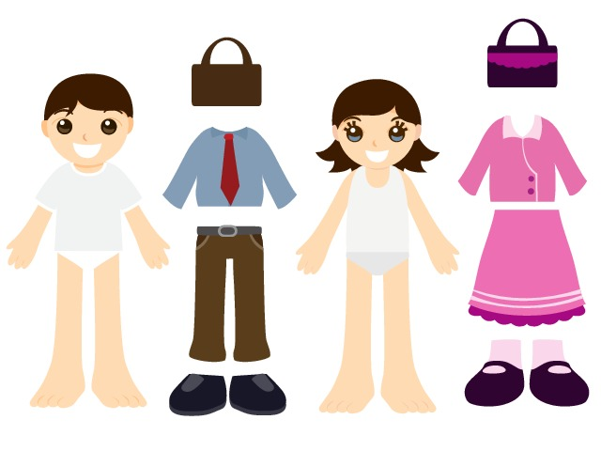
Voici un sac à main très chic. Nous avons ce sac en rose et en bleu aussi à rayures et à pois. Il est en cuir et ce sac va bien avec un pantalon décontracté ou une jupe élégante. Tu peux porter ce sac à main pour une soirée en hiver ou un pique-nique au parc en été. Il coûte 50 €. C’est très bon marché, n’est-ce pas ?

