Leçon 5.2 Devoirs 2 Nom ___________________________________

A. Aller à: Read what the following people like doing. Then write a sentence telling where they are going using the verb aller.
the pool a restaurant the movies the museum the stadium
the beach the library a concert a mall
1. Philippe et Jean-Louis aiment jouer au football. _______________________________________
2. Mlle Bellamy aime l’art moderne. _____________________________________________________
3. Brigitte aime les westerns. ___________________________________________________________
4. Paul et Marc aiment la musique. _____________________________________________________
5. J’aime regarder les magazines français. _______________________________________________
6. Tu aimes diner en ville. ______________________________________________________________
7. Nous aimons nager. _________________________________________________________________
8. Vous aimez le shopping. ____________________________________________________________
B. Le Weekend: Say that the following people WILL do each of the following activities this weekend. Use the future tense.
exemple: Paul / swim Paul va nager.
1. Je / travel ____________________________________________
2. Tu / play basketball ____________________________________________
3. Nous / work ____________________________________________
4. Ils / watch movies ____________________________________________
5. Vous / go to the park ____________________________________________
6. Elle / study ____________________________________________

C. En Eté: Say that the following people WON’T do each of the following activities this summer. Use the future tense.
exemple: Paul / sing Paul ne va pas chanter.
1. Je / study ____________________________________________
2. Tu / listen in class ____________________________________________
3. Nous / go to the library ____________________________________________
4. Ils / look at the teacher ____________________________________________
5. Vous / be in school ____________________________________________
6. Elle / eat at the cafeteria ____________________________________________

D. Au Futur: Use the pictures to describe what each person will do in the future. Include where, when, why and with whom.
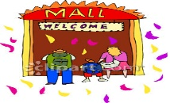
Je vais faire du shopping ce weekend avec mes amis au centre commercial pour acheter un livre en français.

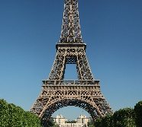
Madame ________________________________________________________________________________________
___________________________________________________________________________________________________.
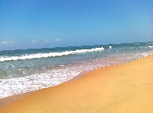
Nous ___________________________________________________________________________________________
__________________________________________________________________________________________________.
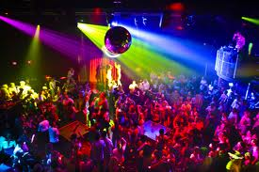
Mes amis ______________________________________________________________________________________
___________________________________________________________________________________________________.

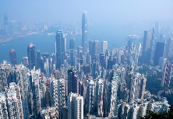
Je _______________________________________________________________________________________________
__________________________________________________________________________________________________.

E. Le Futur: What do you and your friends plan to do (or not do) this weekend? Use the future tense to write at least 10 sentences!
______________________________________________________________________________________________________________________________________________________________________________________________________________________________________________________________________________________________________________________________________________________________________________________________________________________________________________________________________________________________________________________________________________________________________________________________________________________________________________________________________________________________________________________________________________________________________________________________________________________________________________________________________________________________________________________________________________________________________________________________________________________________

