Leçon 5.2 Devoirs 1 Nom ___________________________________

A. Où vas-tu?: You are going to the following locations today. Write this out in French.

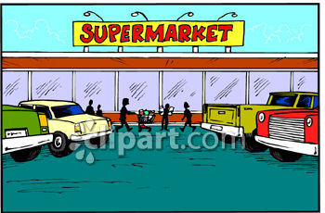

Je vais…

___________________ _____________________ _______________________ ______________________

Now teach a family member how to ask “Where are you going?” Then answer the question aloud for each of the above pictures: Signature: ____________________

Exemple: Où vas-tu? I’m going to the store (say this in French!)

B. Le Verbe ALLER: Translate the following phrases.

I go:________________________ We go: ____________________
You go: _____________________ You all go: _________________
She goes: ____________________ They go: ___________________

C. Le Vocabulaire: Determine where the following people are going by reading the description of what they do there. Choose from the word bank below and include the correct from of au/à la/à l’/aux.

1. Je regarde la télé. Je fais mes devoirs. Je range ma chambre. Je _______ ______________________________
2. Il fait une promenade. Il joue au foot. Il rencontre des amis. Il _______ ______________________________
3. Elle lit un livre. Elle étudie. Elle est seule. Elle _______ ______________________________
4. Tu danses. Tu bavardes. Tu écoutes la musique. Tu _______ ___________________________
5. Il nage. Il bronze. Il fait du surf. Il _______ ______________________________

the beach the library my house the park the club
D. Le Vocabulaire: According to the pictures, state where the following people are going. Be sure to use complete sentences.

Je _____________________________________________________________________
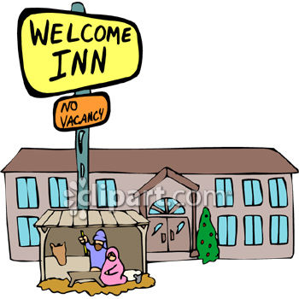 Tu _____________________________________________________________________
Il _______________________________________________________________________
Nous ___________________________________________________________________
Vous _______________________________________________________________________
Elles _______________________________________________________________________
Je _________________________
Tu _________________________
Il ___________________________

Nous ______________________
Vous __________________________
Elles ___________________________

