FR 2 Devoirs 4.1.2 Nom ___________________________________
A. La Pratique Orale: Write a brief description of the sports below. You could include who plays the sport, your opinion of the sport, what happens at a game, etc. Then tell your parent about it in French! Intl: _______
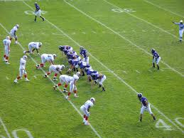
__________________________________________________________________________________________

__________________________________________________________________________________________

__________________________________________________________________________________________
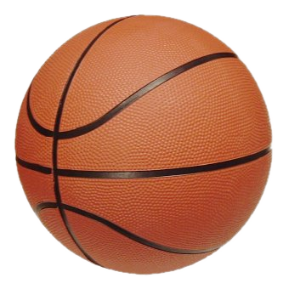

__________________________________________________________________________________________

__________________________________________________________________________________________

__________________________________________________________________________________________

B. Les Vêtements: Pick two of the following people and describe what they are wearing. You can guess colors too!
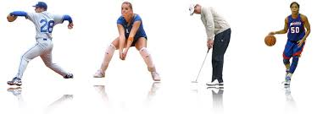
__________________________________________________________________________________________

__________________________________________________________________________________________

__________________________________________________________________________________________

__________________________________________________________________________________________

__________________________________________________________________________________________

__________________________________________________________________________________________

C. Le Pronoms: Replace each underlined noun with le, la, l’ or les.

1. Je trouve le film intéressant. Je _______ trouve intéressant.

2. Nous regardons Serena Williams. Nous ________ regardons.

3. Il aime la musique. Il ________ aime.

4. Est-ce que tu regardes les Jazz? Oui, je _______ regarde.

5. Il trouve Stephen Curry génial. Il ________ trouve génial.

6. Ils portent des crampons. Ils ________ portent.

7. Tu achètes des baskets? Tu ________ achètes?
D. Le Sport: Label the following parts of sports events:
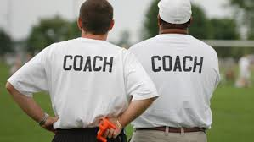
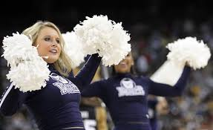
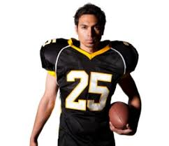
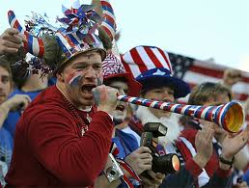

________________________ _______________________________ ________________________________
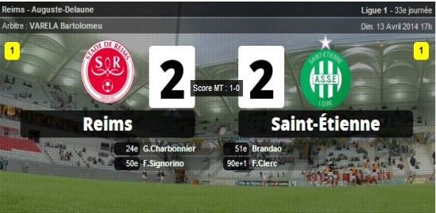
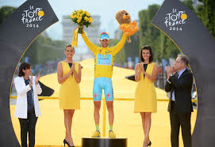
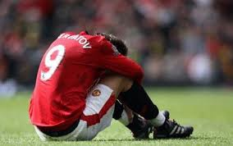

________________________ _______________________________ ________________________________

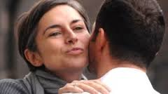
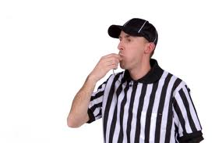
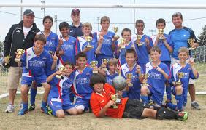
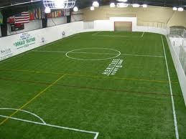

________________________ _______________________________ ________________________________

E. Un Match: Imagine you are attending a game. Write a complete sentence about what happens according to the pictures.




