FR 2 Devoirs 4.1.1 Nom ___________________________________
A. Le Film: Write a brief description of the films below. You could include who is in the movie, your opinion of the movie, a simplified plot explanation, etc. Then tell your parent about it in French! Intl: _______

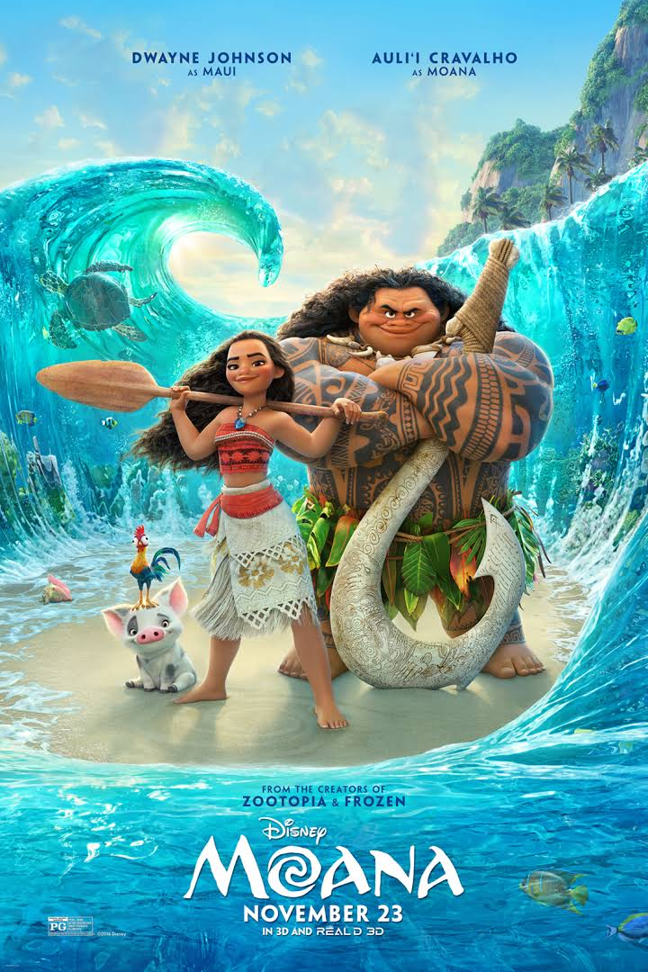
___________________________________________________________________________________________
__________________________________________________________________________________________

__________________________________________________________________________________________

__________________________________________________________________________________________

__________________________________________________________________________________________

__________________________________________________________________________________________

__________________________________________________________________________________________
_____

__________________________________________________________________________________________

__________________________________________________________________________________________

__________________________________________________________________________________________

__________________________________________________________________________________________

__________________________________________________________________________________________

__________________________________________________________________________________________

__________________________________________________________________________________________

B. La Description: Pick ONE of the following people and describe what they are wearing. You can use colors too!

__________________________________________________________________________________________

__________________________________________________________________________________________

__________________________________________________________________________________________

__________________________________________________________________________________________

__________________________________________________________________________________________

__________________________________________________________________________________________

__________________________________________________________________________________________

__________________________________________________________________________________________

__________________________________________________________________________________________

__________________________________________________________________________________________

__________________________________________________________________________________________

C. Le Film: Label the following types of movies:

________________________ _______________________________ ________________________________

________________________ _______________________________ ________________________________

________________________ _______________________________

D. Les Acteurs: Who is your favorite actor and actress? Tell about the roles they have played and why they are your favorite!

ACTEUR: _______________________________________________________________________________

__________________________________________________________________________________________

ACTRICE: _______________________________________________________________________________

__________________________________________________________________________________________

