FR 3 Devoirs 4.1.1 Nom ___________________________________
A. La Pratique Orale: Write a sentence saying what the following people are going to do in the future and why. Then tell a parent.
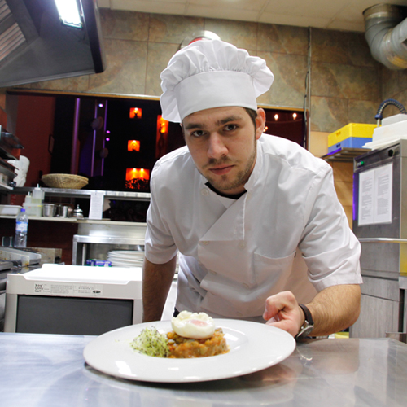
Intl: ____________
1 2 3

1________________________________________________________________________________________2________________________________________________________________________________________3________________________________________________________________________________________
4 5 6

4________________________________________________________________________________________5________________________________________________________________________________________6________________________________________________________________________________________
B. Le Vocabulaire: Given the two choices, write which career is better, in your opinion, and why.
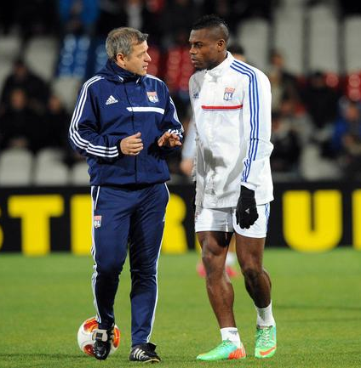
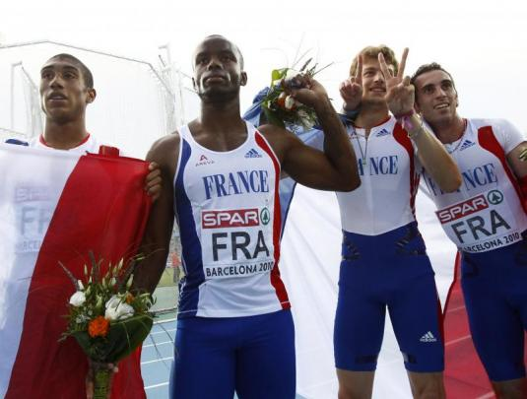
1. vs. ____________________________________________

____________________________________________

____________________________________________

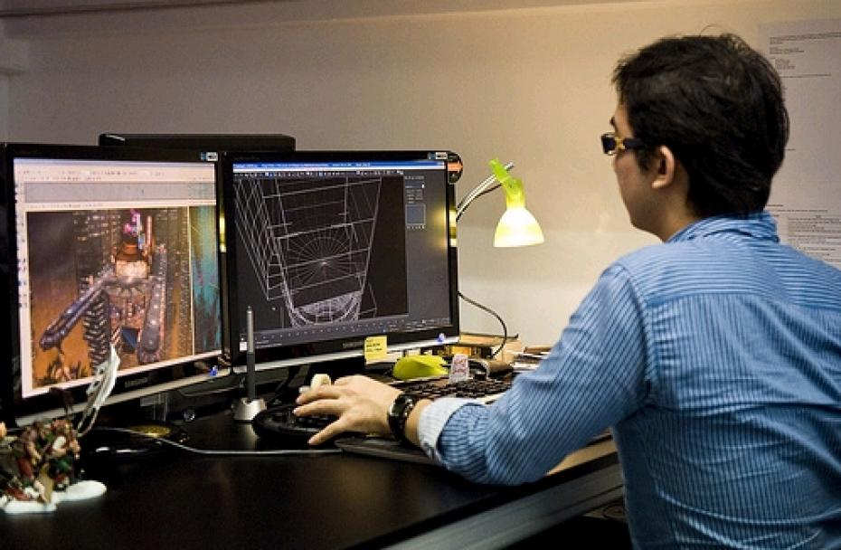
2. vs. ____________________________________________
____________________________________________

____________________________________________

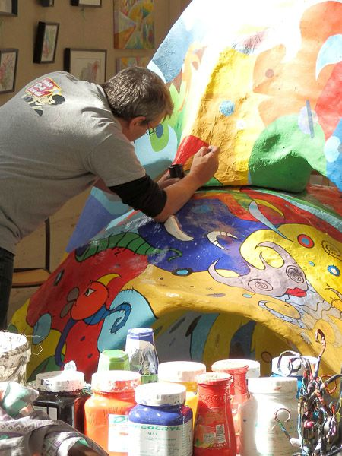
3. vs. ____________________________________________

____________________________________________

____________________________________________

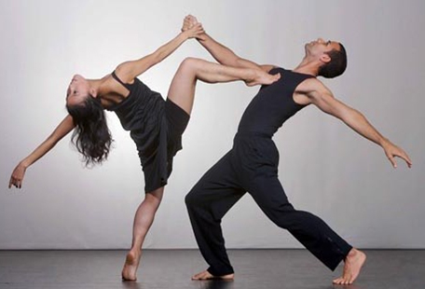
4. vs. ____________________________________________

____________________________________________

____________________________________________

5. vs. ____________________________________________

____________________________________________

____________________________________________

C. La Pratique Ecrite: Write two paragraphs. In the first, describe which careers you like and dislike and the reasons why. In the second, describe the career you'd like to have the most and why.

________________________________________________________________________________________________________________________________________________________________________________________________________________________________________________________________________________________________________________________________________________________________________
________________________________________________________________________________________________________________________________________________________________________________________________________________________________________________________________________________________________________________________________________________________________________
________________________________________________________________________________________________________________________________________________________________________________________________________________________________________________________________________________________________________________________________________________________________________
__________________________________________________________________________________________

