FR 3 Devoirs 3.2.3 Nom ___________________________________

A. La pratique orale: Write a short summary of what this person was like as a child and what he used to do using the imparfait. Then share your story with a parent.
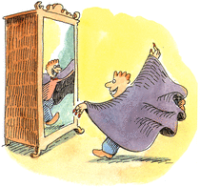
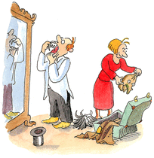
Intl: ______
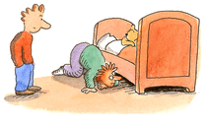

________________________________________________________________________________________
________________________________________________________________________________________
________________________________________________________________________________________
________________________________________________________________________________________
________________________________________________________________________________________
________________________________________________________________________________________

B. Complete the following sentences about your childhood with the imparfait of each verb.

- Je ne (regarder) ________________ jamais la télé et je ne (lire) __________________ plus de BD.
- Nous (manger) __________________ des biscottes et (écouter) ________________ la radio.
- Tu (télécharger) _________________ des CD et (écrire) ___________________ des emails.
- J’(avoir) ______________ mal à la tête et je me (sentir) _______________ malade.
- C’(être) __________________ magnifique parce qu’il y (avoir) ________________ une piscine.
- Il ne (faire) ____________________ plus froid et il ne (pleuvoir) _____________________ jamais.
- On (prendre) ________________ le bus quand on (sortir) ________________ en ville.
- On (aller) _________________ en France en vacances et nous (rester) ______________ au camping.
- Quand j’(être) ______________ jeune, je (vouloir) __________________ aller à la plage
10. Quand elle (être) ___________ petite, ma sœur (savoir) _________________ se toucher
les pieds.

C. Write about your childhood using the imparfait and the new vocabulary. (5 sentences each)

1. TA MAISON

________________________________________________________________________________________
________________________________________________________________________________________
________________________________________________________________________________________

2. TA FAMILLE

________________________________________________________________________________________
________________________________________________________________________________________
________________________________________________________________________________________

3. TON ÉCOLE

________________________________________________________________________________________
________________________________________________________________________________________
________________________________________________________________________________________

4. TES AMIS

________________________________________________________________________________________
________________________________________________________________________________________
________________________________________________________________________________________

D. For more practice with the imparfait scan this QR code to play an imparfait Sporkle game:

