FR 3 Devoirs 3.2.2 Nom ___________________________________

A. La pratique orale: Using the following pictures write a description of the childhood of a friend using the imparfait and as much unit 3 vocabulary as you can. Then tell a parent.
Intl: ______
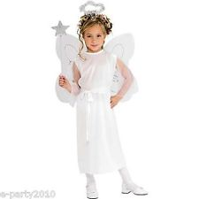
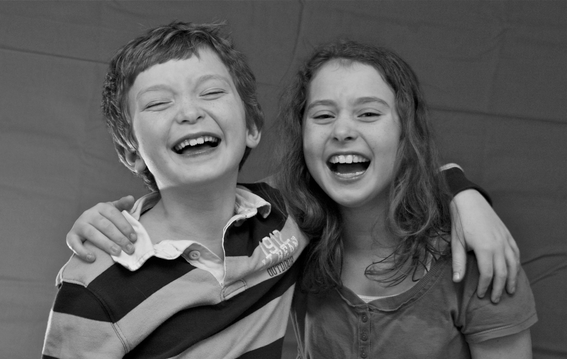

________________________________________________________________________________________
________________________________________________________________________________________
________________________________________________________________________________________
________________________________________________________________________________________
________________________________________________________________________________________
________________________________________________________________________________________

B. Using the imparfait and the pictures, write what these kids were like and what they used to do. Don’t forget to share what they didn’t used to do as well.

Ex: Il était gâté, il ne partagait pas et se comportait mal.

1. __________________________________________________________________

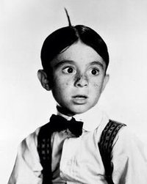

2. _______________________________________________________________________

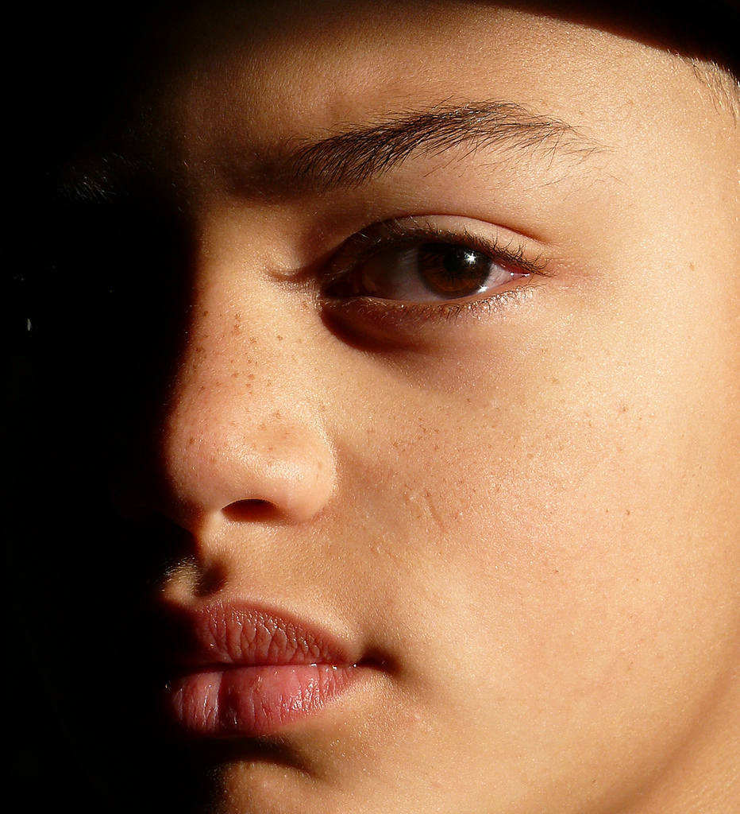

3. _______________________________________________________________________

4. _______________________________________________________________________

5. _________________________________________________________________

6. ______________________________________________________________________

C. Complete the following sentences with the imparfait form of the verb.

- En 1994, j’_______________ (habiter) à Toulouse.
- Pendant notre enfance, nous _______________ (jouer) au tennis.
- Est-ce que tu _______________ (finir) toujours à 18 heures?
- Tous les jours, elle lui _______________ (rendre) visite.
- Vous _______________ (aller) souvent au cinéma.
- Avant ils _______________ (voyager) beaucoup.
- Est-ce que tu _______________ (connaître) ce chanteur?
- Elle _______________ (prendre) le bus tous les jours.
- Ils _______________ (lire) tous les matins les journaux.
10. En 2005 j’_______________ (avoir)15 ans.

D. For more practice with the imparfait scan this QR code:

