Leçon 3.2 Devoirs 2 Nom _________________________________
A. Create a meal plan for someone trying to eat better. Be sure to include quantities! Then explain why you chose to include each item in the plan to a parent in French. Intl: _______
 | LE MENU | POURQUOI
Le petit-déjeuner
Le déjeuner

Le goûter

Le dîner

B. Make a list of three foods that answer the following prompt: Qu’est-ce qui est mauvais pour la santé? Explain why to the right.
____________________________ __________________________________________________________

____________________________ __________________________________________________________

____________________________ __________________________________________________________

C. Les Repas: Imagine that you are planning the following meals. Make a list of the things you need to get at the grocery store. Be sure to include quantities!
un dîner élégant un pique-nique

_________________________________________ ____________________________________________

_________________________________________ ____________________________________________

_________________________________________ ____________________________________________

un déjeuner à l’école un petit déjeuner en hiver

_________________________________________ ____________________________________________

_________________________________________ ____________________________________________

_________________________________________ ____________________________________________

D. Read the following information and answer the questions below.
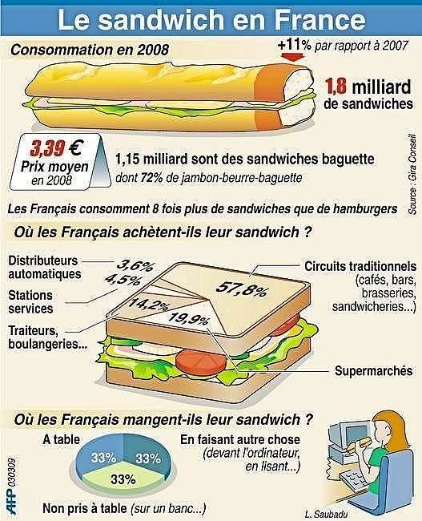

1. Combien de sandwiches est-ce que les français mangent? _____________________________

2. Combien de français mangent à table? _______________________________________________

3. Est-ce que les français mangent plus de sandwiches ou d’hamburgers? ________________

4. Combien de français mangent le sandwich en faisant autre chose? ____________________

5. Où est-ce que les français achètent leurs sandwiches? ________________________________

6. Combien coûte un sandwich en France? ______________________________________________

7. Quel sandwich est-ce que les Français préfèrent? _____________________________________

