FR 3 Devoirs 3.2.1 Nom ___________________________________

A. La pratique orale: Write a sentence about what the following people were like and what they liked to do when they were kids. Then tell a parent.
Intl: ______
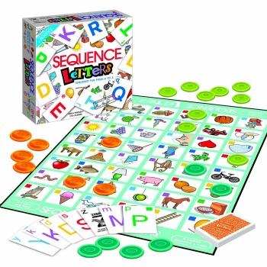
1. Paul 2. Nous

_______________________________________ _______________________________________
_______________________________________ _______________________________________
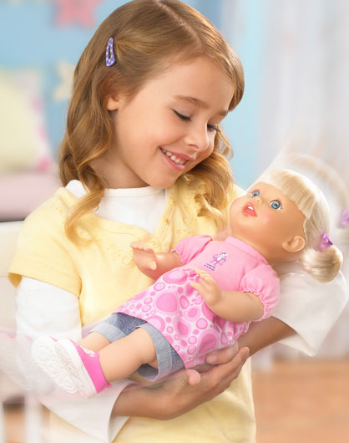
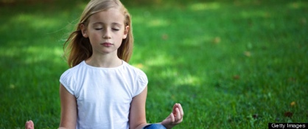
3. Mes soeurs 4. Vous

_______________________________________ _______________________________________
_______________________________________ _______________________________________
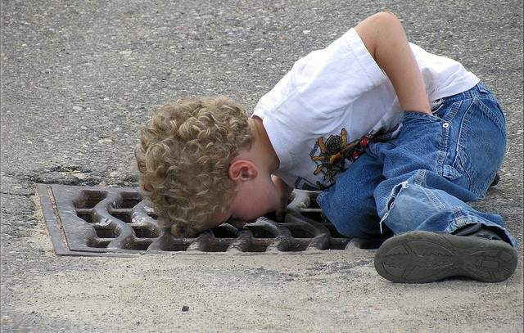
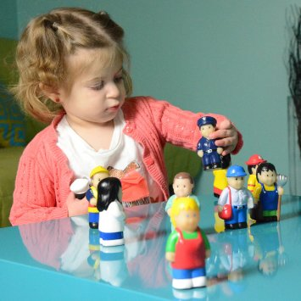

5. Je 6. Tu

_______________________________________ _______________________________________
_______________________________________ _______________________________________

B. Complete the following sentences using the passé composé to describe what these people did last weekend.

1. M. Arnaud ___________________________________________________________ (aller) au parc.

2. Jeanne ________________________________________________________ (visiter) à la banque.

3. Je ________________________________________________________ (marcher) à la campagne.
4. Thierry et Christophe ______________________________________________ (dormir) à l’hôtel.

5. Toi et tes amis __________________________________ (acheter des vêtements) au magasin.

6. Vous _________________________________________________________________ (nager) au lac.

C. Complete the following sentences using the imparfait to describe what people used to do when they were young.

1. M. Arnaud ____________________________________________________________ (aller) au parc.

2. Jeanne _________________________________________________________ (visiter) à la banque.

3. Je _________________________________________________________ (marcher) à la campagne.
4. Thierry et Christopher _______________________________________________ (dormir) à l’hôtel.

5. Toi et tes amis ___________________________________ (acheter des vêtements) au magasin.

6. Vous __________________________________________________________________ (nager) au lac.

D. La pratique écrite Write a paragraph of at least 15 sentences describing what you did when you were a child. Please use vocabulary from previous units and the current vocabulary list.
__________________________________________________________________________________________________________________________________________________________________________________________________________________________________________________________________________________________________________________________________________________________________________________________________________________________________________________________________________________________________________________________________________________________________________________________________________________________________________________________________________________________________________________________________________________________________________________________________________________________________________
E. For additional explanation of the For additional practice using the
imparfait scan this QR code: imparfait scan this QR code:

