Leçon 3.2 Devoirs 1 Nom _________________________________

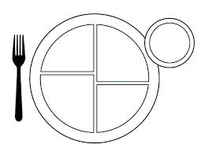
A. Draw and label a typical dinner you eat. Then teach a parent how to say the food items. Intl: _______

B. Make a list of food items that belong in each of the following categories:

Il y a beaucoup de calories: Il y a des vitamines

___________________________________________ _____________________________________________

___________________________________________ _____________________________________________

___________________________________________ _____________________________________________

___________________________________________ _____________________________________________

Il y a trop de lipides Il y a des allergènes

___________________________________________ _____________________________________________

___________________________________________ _____________________________________________

___________________________________________ _____________________________________________

___________________________________________ _____________________________________________

C. Answer the following questions in French. Write at least 3 complete sentences for each question.

1. Qu’est-ce qui est votre régime quotidien?

__________________________________________________________________________________________

__________________________________________________________________________________________

__________________________________________________________________________________________

2. Qu’est-ce que tu devrais manger pour être en bonne santé?

__________________________________________________________________________________________

__________________________________________________________________________________________

__________________________________________________________________________________________

3. Qu’est-ce qui est mauvais(e) pour la santé?

__________________________________________________________________________________________

__________________________________________________________________________________________

__________________________________________________________________________________________

4. Qu’est-ce qui compose un régime alimentaire équilibré?

__________________________________________________________________________________________

__________________________________________________________________________________________

__________________________________________________________________________________________
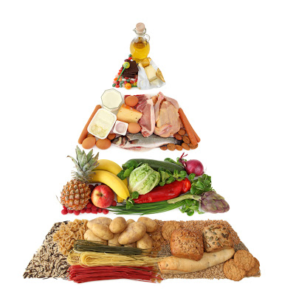
D. Label the parts of the food pyramid and list the daily recommendations for each category:

_____________________________________________________________________

________________________________________________________________

_____________________________________________________________

__________________________________________________________

