FR 3 Devoirs 3.1.3 Nom ___________________________________

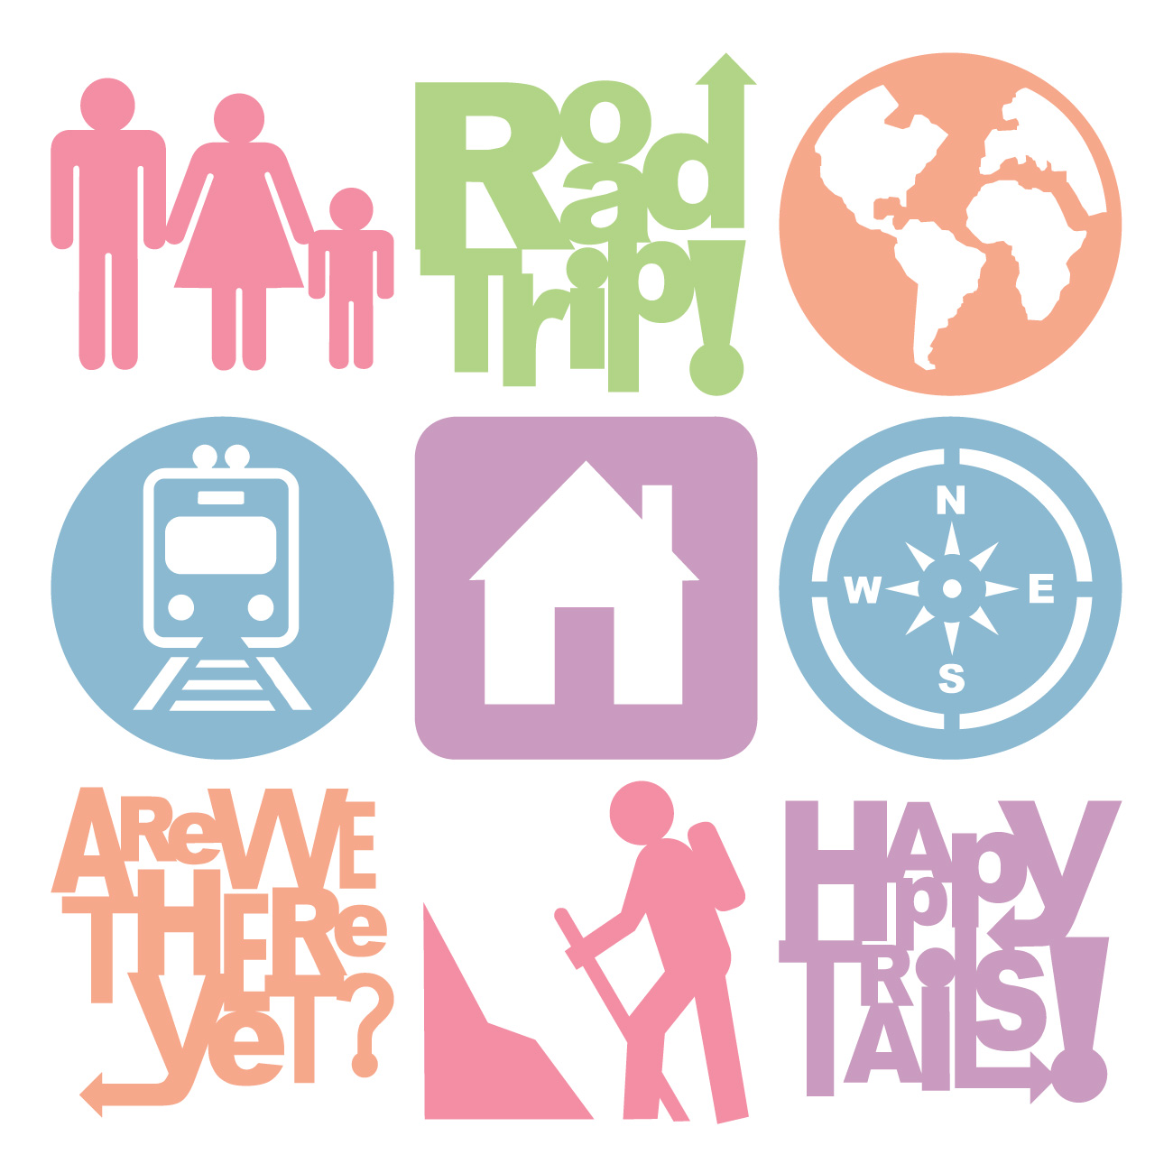
A. La pratique orale: Tell a parent three places that you went yesterday and three places that you didn’t go yesterday.
Intl: ______

Hier, je_________________________________ Hier je ne____________________________________

Hier, je_________________________________ Hier je ne____________________________________

Hier, je_________________________________ Hier je ne____________________________________

B. Translate the following sentences into French, being careful to use ETRE in the past tense correctly.

1. Where did you go? ___________________________________________________________________
2. I went to the store. ___________________________________________________________________
3. Where did he go? ____________________________________________________________________
4. He went to the movies. _______________________________________________________________
5. Where did you guys go (f)? ____________________________________________________________
6. We went to the hospital. ______________________________________________________________

C. Farid, a Moroccan student, spent a month in France last summer. Complete the description of her trip by using the passé composé of the suggested verbs.

1. (arriver) Elle ____________ _________________________ à Paris le 12 juillet.

2. (rester) Elle ____________ __________________________ 3 semaines dans cette ville.

3. (manger) Elle ____________ _______________________________ aux restaurants élégants.

4. (monter) Elle ____________ _______________________________ à La Tour Eiffel.

5. (voir) Elle ____________ _______________________________ La Mona Lisa.

6. (partir) Le 2 août, elle ____________ __________________________ pour la Normandie.

7. (prendre) Elle ____________ ____________________________ beaucoup de photos.

8. (se promener) Elle ____________ _______________________________ sur la plage.

9. (revenir) Elle ____________ ______________________________ à Paris le 7 août.

10. (rentrer) Elle ____________ ____________________________ au Canada le 10 août.

D. Les Pronoms: Replace the underline nouns by the correct pronouns. Put the pronoun in the proper position. Check for DO PP OUI if you use position 3!

1 Nous allons lire l’histoire à Gwyn. ________________________________________________
2 Nous avons lu l’histoire à Gwyn. ________________________________________________
3 Nous lisons l’histoire à Gwyn. ________________________________________________
4 Tu ne vois pas les voitures! ________________________________________________
5 Tu ne veux pas voir les voitures! ________________________________________________
6 Tu n’as pas vu les voitures! ________________________________________________

E. Respond to the following prompts about Fall Break in paragraph form.

- Share 3 places you WENT.
- Tell 1 place you didn’t go
- Share 1 thing you did at each place
- Tell 1 thing you wanted to do, but didn’t.

________________________________________________________________________________________________________________________________________________________________________________________________________________________________________________________________________________________________________________________________________________________________________________________________________________________________________________________________________________________________________________________________________________________________________________________________________________________________________________________________________________________________________________________________________________
____________________________________________________________________________________________________________________________________________________________________________________

