FR 3 Devoirs 3.1.1 Nom ___________________________________

A. La Pratique Orale: Tell a parent what the following people DID (1-3) DIDN’T (4-5) do last weekend at these places using the verbs in parenthesis.
Intl: ______
1. Paul _______________________________________________________________

(écouter) _______________________________________________________________

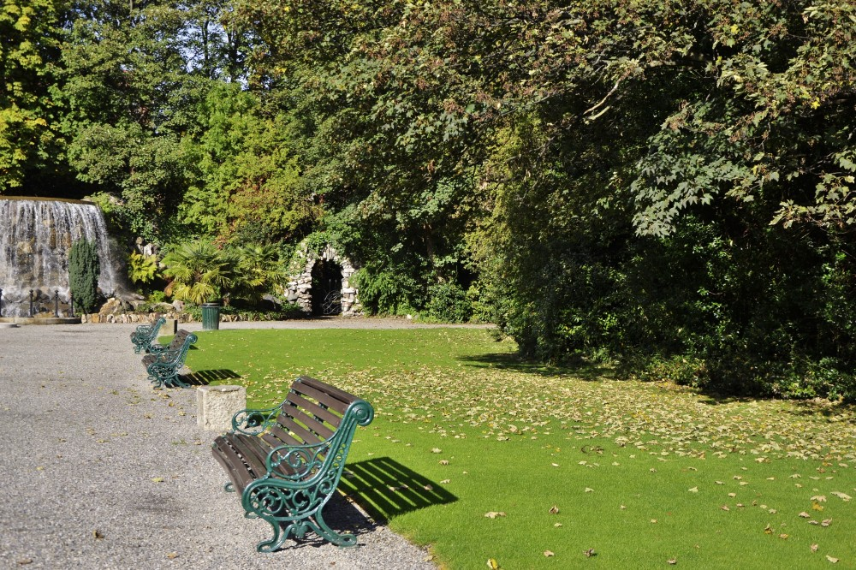
2. Mes sœurs __________________________________________________________

(marcher) _______________________________________________________

3. Jean-Luc et Thierry ____________________________________________________

(jouer) ____________________________________________________

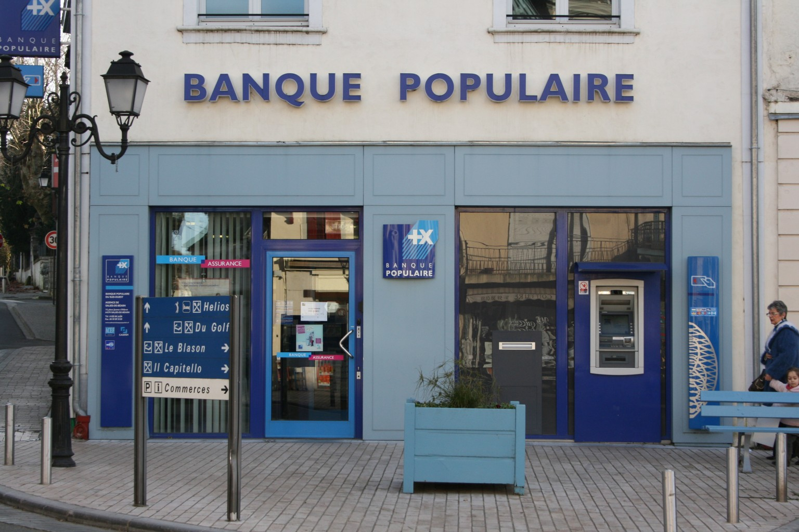
4. Ma famille _________________________________________________________

(acheter) _________________________________________________________

5. Vous _________________________________________________________________

(visiter) _________________________________________________________________

B. Describe what the following people DID last weekend at these places.

1. Moi et mes frères _____________________________________________________ au parc.

2. Nicole _____________________________________________________ à la banque.

3. Je _____________________________________________________ à la campagne.

4. Paul et Jean _____________________________________________________ à l’hôtel.

5. Toi et tes amis _____________________________________________________ au magasin.

6. Claire et Sophie _____________________________________________________ au lac.
C. Describe what the following people did NOT do last weekend.

1. (acheter) Mélanie ___________________________________________ des fruits.

2. (faire) Hélène et Julien ___________________________________________ une promenade.

3. (voir) Nous ___________________________________________ des lions dans le parc!

4. (avoir) Mon frère ___________________________________________ un accident.

5. (prendre) Vous ___________________________________________ un bon repas au café.

D. Write an 8-10 sentence paragraph telling what chores you were and were not responsible for around the house last year using vocabulary from the vocabulary list.

______________________________________________________________________________________________________________________________________________________________________________________________________________________________________________________________________________
______________________________________________________________________________________________________________________________________________________________________________________________________________________________________________________________________________
______________________________________________________________________________________________________________________________________________________________________________________________________________________________________________________________________________
______________________________________________________________________________________________________________________________________________________________________________________________________________________________________________________________________________
______________________________________________________________________________________________________________________________________________________________________________________________________________________________________________________________________________

