Leçon 2.3 Devoirs 3 Nom ___________________________________

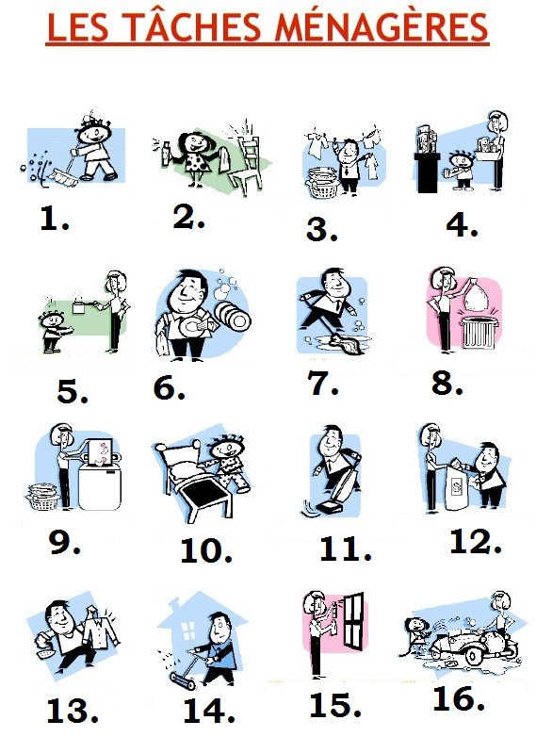
A. Say whether or not you MUST do the following chores.
1. __________________________________________________________________________
2. __________________________________________________________________________
3. __________________________________________________________________________
4. __________________________________________________________________________
5. __________________________________________________________________________
6. __________________________________________________________________________
7. __________________________________________________________________________
8. __________________________________________________________________________
9. __________________________________________________________________________
10. __________________________________________________________________________
11. __________________________________________________________________________
12. __________________________________________________________________________
13. __________________________________________________________________________
14. __________________________________________________________________________
15. __________________________________________________________________________
16. __________________________________________________________________________

B. Pick 4 chores and say where you WILL do them.
a. __________________________________________________________________________
b. __________________________________________________________________________
c. __________________________________________________________________________
d. __________________________________________________________________________

C. Pick 4 chores and say when you WILL do them.
a. __________________________________________________________________________
b. __________________________________________________________________________
c. __________________________________________________________________________
d. __________________________________________________________________________

