FR 1 Devoirs 2.2.1 Nom ___________________________________
Classe _________________________________

A. La Description: Write the following physical characteristics (both the masculine & feminine forms) in French.
1. 2. 3. 4. 5.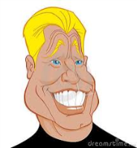 6.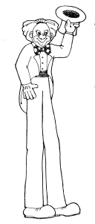
masculine feminine
1. ________________________________ ________________________________
2. ________________________________ ________________________________
3. ________________________________ ________________________________
4. ________________________________ ________________________________
5. ________________________________ ________________________________
6. ________________________________ ________________________________

B. La Description: Compare the appearance of your mother and father. Begin your sentences with il/elle est…

maman papa

1. _____________________________________ _____________________________________
2. _____________________________________ _____________________________________
3. _____________________________________ _____________________________________
4. _____________________________________ _____________________________________
5. _____________________________________ _____________________________________
6. _____________________________________ _____________________________________

C. La Description: Describe your favorite cousin. Include name, age, personality, appearance, hair color and eye color.
__________________________________________________________________________________________________________________________________________________________________________________________________________________________________________________________________________________________________________________________________________________________________________________________________________________________________________________________________

