Leçon 2.1 Devoirs 2 Nom ___________________________________

A. La Pratique Orale: Describe 3 friends to one of your parents. Write down 4 of the adjectives you used for each friend. Parent Initial ________

Ami 1 Ami 2 Ami 3
_____________________ _____________________ _____________________
_____________________ _____________________ _____________________
_____________________ _____________________ _____________________
_____________________ _____________________ _____________________

B. La Pratique Ecrite: Put the following adjectives into the sentences in their correct form and position.
1 Jacques connait une femme. (pretentious / short)
_______________________________________________________________________
2 Thérèse a un ami. (nervous / old)
_______________________________________________________________________
3 Nous aimons nos amies. (good / understanding)
_______________________________________________________________________
4 J’écoute mes sœurs. (funny / nice)
_______________________________________________________________________
5 Françoise n’aime pas les garçons. (selfish / bad)
_______________________________________________________________________
6 M. Renard préfère les élèves. (considerate / ponctual)
_______________________________________________________________________
7 Albert est un homme. (handsome, ambitious)
_______________________________________________________________________

C. La Pratique Supplémentaire: Use the following QR codes for extra practice!


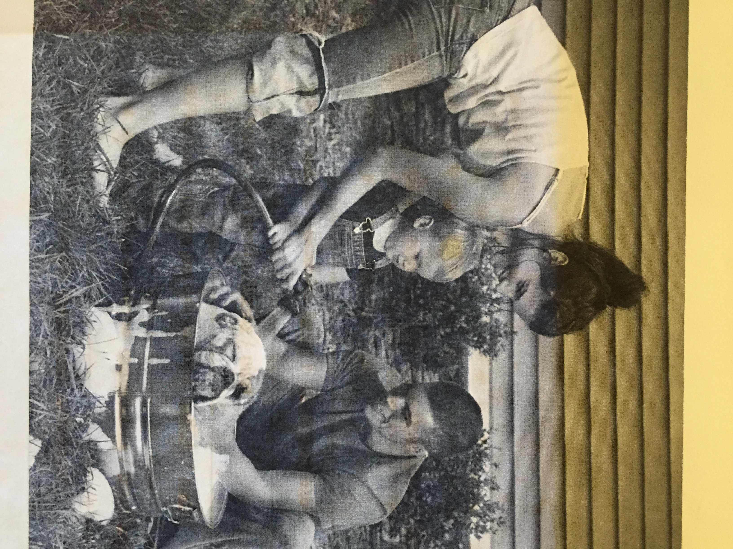
D. La Pratique Ecrite: Name and compare the family members below. Be creative!
____________________________________________________________________________________________________________________________________
____________________________________________________________________________________________________________________________________
____________________________________________________________________________________________________________________________________
____________________________________________________________________________________________________________________________________
____________________________________________________________________________________________________________________________________

E. La Pratique Ecrite: Décrivez un/une de vos amis en détail. Utilisez:
- les adjectifs de votre liste de vocabulaire
- il/elle est ET il/elle n’est pas
- c’est une fille… OU c’est un garçon…
- les comparaisons

Fill the space provided!
____________________________________________________________________________________________________________________________________________________________________________________
____________________________________________________________________________________________________________________________________________________________________________________
____________________________________________________________________________________________________________________________________________________________________________________
____________________________________________________________________________________________________________________________________________________________________________________
____________________________________________________________________________________________________________________________________________________________________________________
____________________________________________________________________________________________________________________________________________________________________________________

