Leçon 1.2 Devoirs 2 Nom ___________________________________

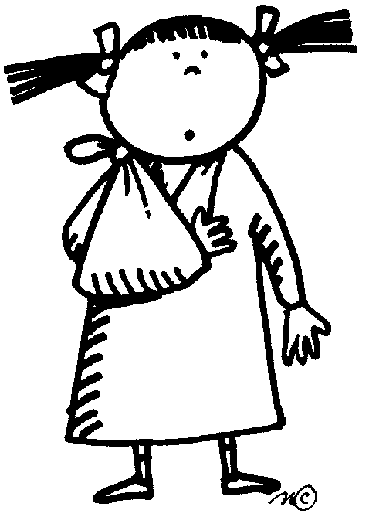
A. Le Vocabulaire: Write a conversation where two people ask each other how they're doing and give their answers according to the pictures.
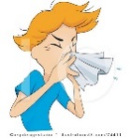
Person 1: Bonjour, ça-va ?
Person 2: Non, ça ne va pas, j'ai une rhume. Et toi?
Person 1: Non, ça ne va pas, je me suis cassé le bras.

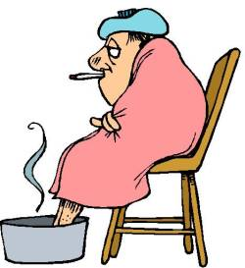
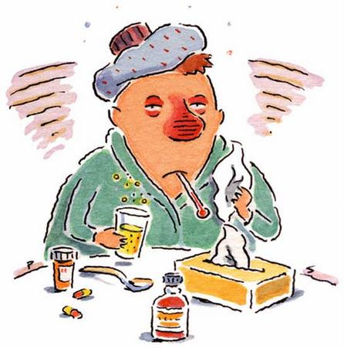

1. Person 1 ___________________________________________
Person 2 ___________________________________________
Person 1 ___________________________________________
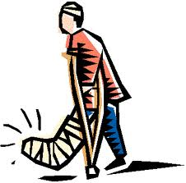
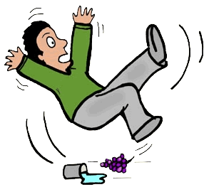

2. Person 1 ________________________________________
Person 2 ________________________________________
Person 1 ________________________________________
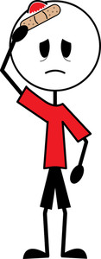
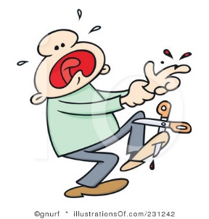
3. Person 1 __________________________________________
Person 2 __________________________________________
Person 1 __________________________________________

B. L’Imparfait: For each of the following pictures, say what was going on using the imparfait and je.
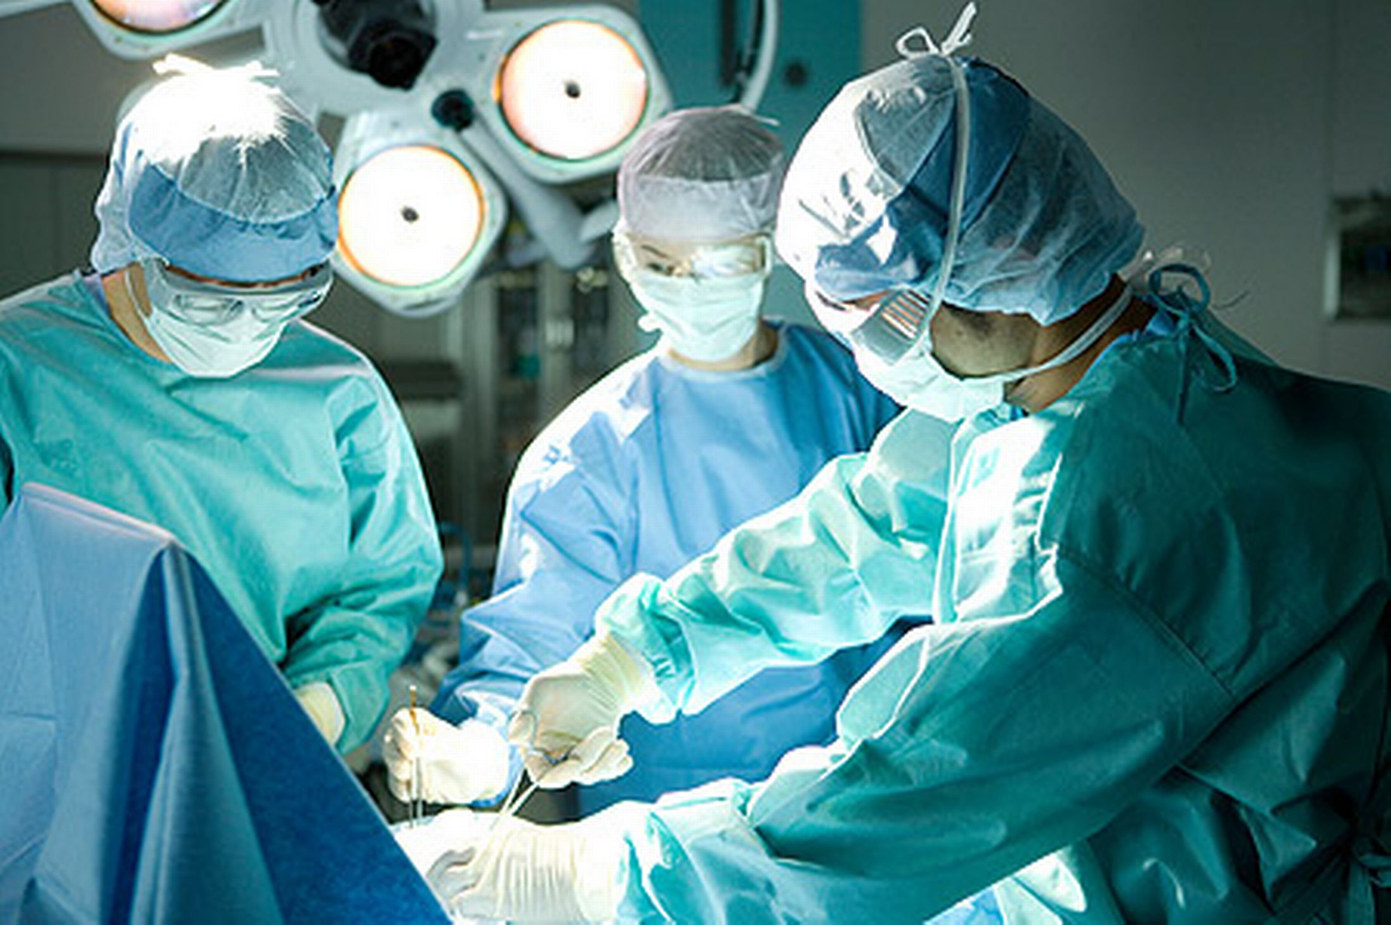
_______________________________________________________________________
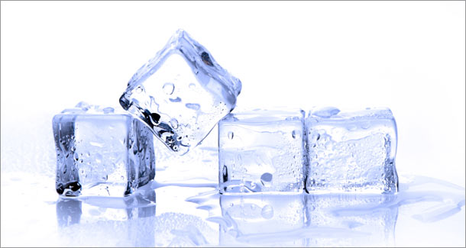

________________________________________________________________________
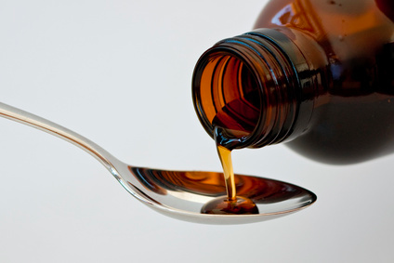

_____________________________________________________________________
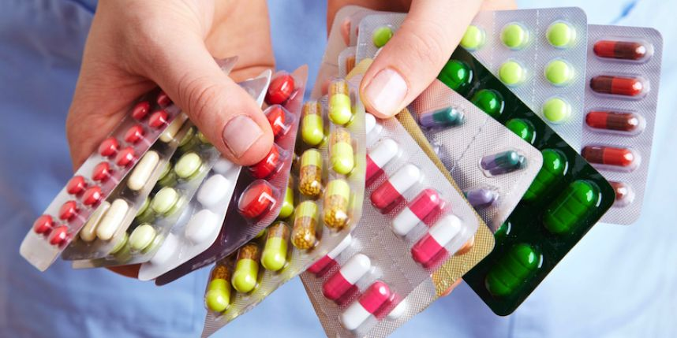

________________________________________________________________________
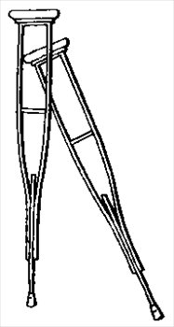

____________________________________________________________________________

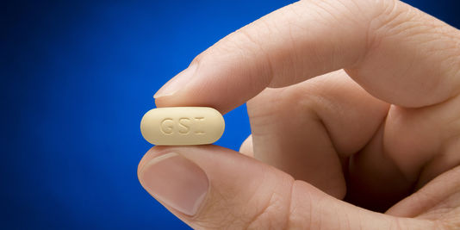
________________________________________________________________________
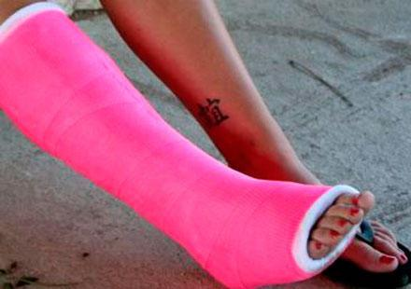

___________________________________________________________________________
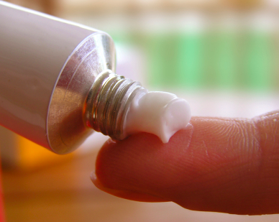

__________________________________________________________________________________________

C. L’Imparfait: Use the imparfait and a variety of verbs to say what people at your house were doing last night at 9:00pm.

Ex. Hier soir, à 21h00, mon père dormait.
____________________________________________________________________________________________________________________________________________________________________________________________________________________________________________________________________________________________________________________________________________________________________________________________________________________________________________________________________________________________________________________________________________________________

