Leçon 1.2 Devoirs 1 Nom ___________________________________
A. La Pratique Orale: For each of the following pictures, write and give the recommendation to a parent.
Il faut… Intl: _______

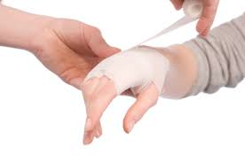
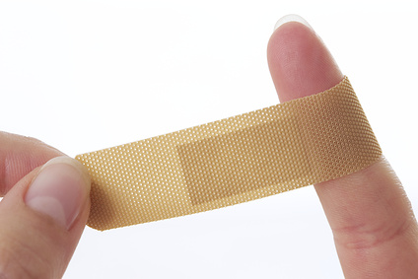

________________ ___________________ __________________ ________________ _______________

________________ ___________________ __________________ ________________ _______________

B. Le Vocabulaire: Put the following in the correct order and in French.

You must rest. _______________________________________________

You must use a bandaid _______________________________________________

You must make a doctor’s appointment _______________________________________________

You must use some ointment ________________________________________________

You must pay attention ________________________________________________

You must visit the doctor. ________________________________________________

C. Le Vocabulaire: For the following picture, say two things each person must DO and two things each person NEEDS:
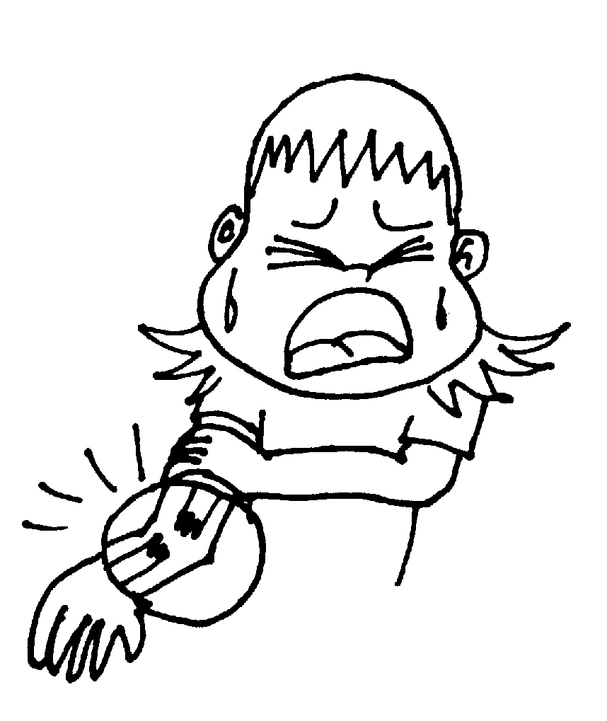

DOIT FAIRE A BESOIN DE

___________________________________ ___________________________________

___________________________________ ___________________________________
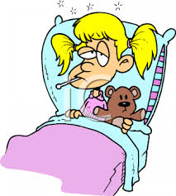

___________________________________ ___________________________________

___________________________________ ___________________________________

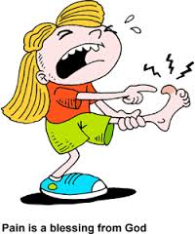
___________________________________ ___________________________________

___________________________________ ___________________________________

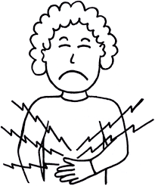

___________________________________ ___________________________________
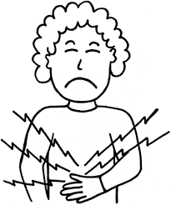
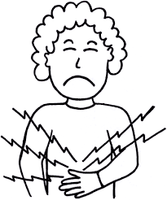
___________________________________ ___________________________________

D. Les Passés: Conjugate the following verbs correctly in both the imparfait and passé compose.

avoir la grippe tomber

passé composé tu_________________________ elle___________________________

imparfait tu_________________________ elle___________________________

se couper vomir

passé composé nous_________________________ ils___________________________

imparfait nous_________________________ ils___________________________

rester au lit se blesser

passé composé vous_________________________ je___________________________

imparfait vous_________________________ je___________________________

