Leçon 1.1 Devoirs 3 Nom ___________________________________
A. La pratique orale: Meet Jean-Claude! He is very clumsy and is always getting hurt Write 6 sentences that describe what has recently happened to him. Then say them out loud to a parent! Intl: _______
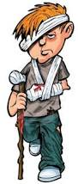
1. ____________________________________________________________________

2. ____________________________________________________________________

3. ____________________________________________________________________

4. ____________________________________________________________________

5. ____________________________________________________________________

6. ____________________________________________________________________

B. Le Passé Composé: Choose the correct helping verb for each sentence (a, est, s’est).

- L’année dernière, Marc_________ tombé.
- Il _________ glissé au bureau.
- Il _________ cassé le bras.
- Il _________ allé à l’hopital.
- Il _________ blessé sévèrement.
- Par consequence, il n’_________ pas voyagé en France avec sa famille

C. Le Passé Composé: Choose the correct helping verb for each sentence (ai, suis, me suis).
- Le weekend dernier, j(e)_________ eu la grippe.
- J(e)_________beaucoup toussé .
- J(e)_________ aussi vomi.
- J(e)_________ resté au lit tout le weekend.
- Je ne _________pas tordu la cheville mais je _________ blessé la gorge en toussant.
D. Write an answer to the question “Qu’est-ce qui s’est passé” for each image. (Be sure to answer in the past tense and include what hurts as a result.)
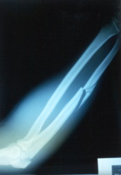
1.______________________________________________________________
________________________________________________________________
2. _____________________________________________________________
________________________________________________________________

3. ______________________________________________________________
_________________________________________________________________

