Leçon 1.1 Devoirs 2 Nom ___________________________________

A. La pratique orale: Make a list of 9 body parts and then teach them to a parent.
Intl: ______

__________________________ ______________________________ ________________________

__________________________ ______________________________ ________________________

__________________________ ______________________________ ________________________

B. Avoir mal: Using the pictures write a short sentence describing a symptom of each person and a second sentence describing what hurts.
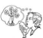
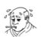
Ex: Elle éternue parce qu’elle a des allergies. Elle a mal à la tête.

1. __________________________________________________________________________
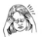
2. __________________________________________________________________________
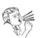
3. __________________________________________________________________________
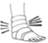
4. __________________________________________________________________________
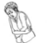
5. __________________________________________________________________________
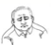
6. __________________________________________________________________________

C. Complete the sentences describing what hurts, circling the correct article and match
with the cause.

1. J’ai mal au/à la _______________________ parce que _____ a. j’ai glissé

2. J’ai mal au/à la ________________________ parce que _____ b. je suis tombé(e)

3. J’ai mal au/à la _______________________ parce que _____ c. je me suis cassé le bras

4. J’ai mal au/à la _______________________ parce que _____ d. j’ai attrapé un rhume

5. J’ai mal au/à la _______________________ parce que _____ e. j’ai des allergies

D. Describe what the following people did NOT do last weekend.

1. (s’acheter) Mélanie ___________________________________________ des fruits.

2. (faire) Hélène et Julien ___________________________________________ une promenade.

3. (voir) Nous ___________________________________________ des lions dans le parc!

4. (aller) Mon frère ___________________________________________ à Paris.

5. (prendre) Vous ___________________________________________ un bon repas au café.

E. By looking at the pictures of the following people. Come up with a sequence of THREE things that happened leading up to what you see.

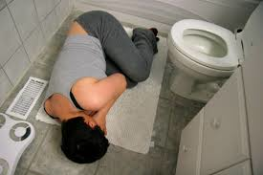
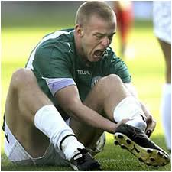
Example: He went upstairs to clean the bathroom. He cleaned the floor. He slipped.

_____________________________________________________

_____________________________________________________














