FR 2 Devoirs 2.1.4 Nom __________________________________
Classe ________________________________

A. La routine quotidienne: Write a sentence for each picture describing what Sophie is doing. (In some sentences, Sophie has changed to we, you guys or they.)

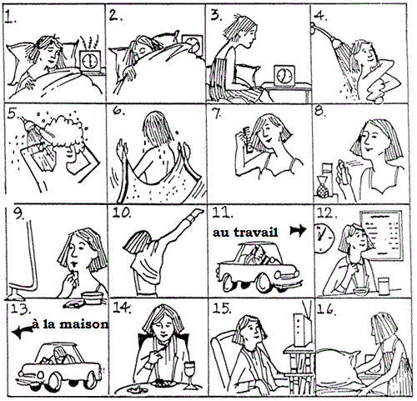

1. ___________________________________________________________________________________
2. Nous _____________________________________________________________________________
3. ___________________________________________________________________________________
4. ___________________________________________________________________________________
5. Vous _____________________________________________________________________________
6. ___________________________________________________________________________________
7. ___________________________________________________________________________________
8. Ils _______________________________________________________________________________
9. ___________________________________________________________________________________
10. ___________________________________________________________________________________
11. Elles ______________________________________________________________________________
12. ___________________________________________________________________________________
13. ___________________________________________________________________________________
14. ___________________________________________________________________________________
15. Nous _____________________________________________________________________________
16. ___________________________________________________________________________________

