FR 1 Devoirs 6.3.2 Nom ___________________________________

A. Accepter une invitation: You have been invited to the following places. Accept the invitation and add why you want to go (preference) and what you will do there (future).

1. Est-ce que tu veux aller au fast-food? 2. Est-ce que tu veux aller à la ville?

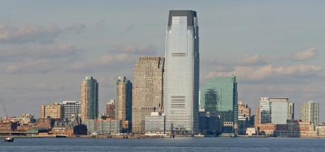

____________________________________________ __________________________________________
____________________________________________ __________________________________________
____________________________________________ __________________________________________
____________________________________________ __________________________________________
____________________________________________ __________________________________________
____________________________________________ __________________________________________

B. Refuser une invitation: You have been invited to the following places. Refuse the invitation and add why you can’t go. Be creative!

1. Est-ce que tu veux aller à la fète? 2. Est-ce que tu veux aller au centre
commercial?
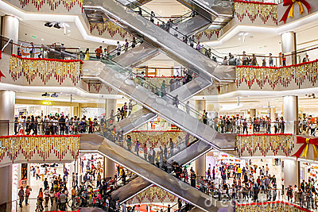

____________________________________________ __________________________________________
____________________________________________ __________________________________________
____________________________________________ __________________________________________
____________________________________________ __________________________________________
____________________________________________ __________________________________________
____________________________________________ __________________________________________

C. Un Dialogue: Write a dialogue between yourself and your grandmother that follows the outline below. Write as much as possible and be creative!

Personne 1 your grandmother extends an invitation to go do something

Personne 2 you refuse the invitation and add why you can’t go

Personne 1 your grandmother extends another invitation to go do something different

Personne 2 you accept the invitation, add why and what you will do there

Personne 1 _________________________________________________________________________

Personne 2 _________________________________________________________________________

_________________________________________________________________________

Personne 1 _________________________________________________________________________

Personne 2 _________________________________________________________________________

_________________________________________________________________________

_________________________________________________________________________

