FR 1 Devoirs 6.3.1 Nom ___________________________________

A. Le Futur: Write what the following people will do tomorrow, according to the pictures. Be sure to use a verb not a location and complete sentences.

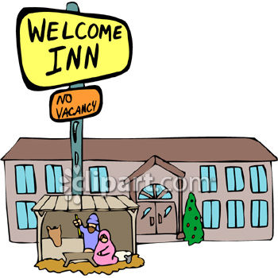
Je __vais faire du shopping_________ Tu _________________________________
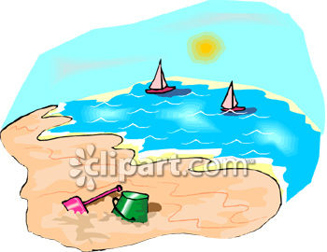
Il _________________________________ Nous _________________________________
Vous _________________________________ Elles _________________________________

B. Le Weekend: Say that the following people WILL do each of the following activities this weekend. Use the future tense.
exemple: Paul / swim Paul va nager.
1. Je / travel ____________________________________________
2. Tu / play basketball ____________________________________________
3. Nous / work ____________________________________________
4. Ils / watch movies ____________________________________________
5. Vous / go to the park ____________________________________________
6. Elle / study ____________________________________________

C. Le Futur: What do you plan to do (or not do) this summer? Use the future tense to write at least 10 sentences!
____________________________________________________________________________________________________________________________________________________________________________________________________________________________________________________________________________________________________________________________________________________________________________________________________________________________________________________________________________________________________________________________________________________________

