FR 2 Devoirs 6.2.1 Nom ___________________________________
A. La pratique orale: For each of the following pictures, write and give the recommendation to a parent.
Il faut… Intl: _______

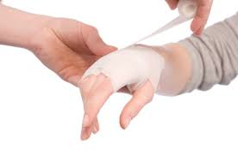
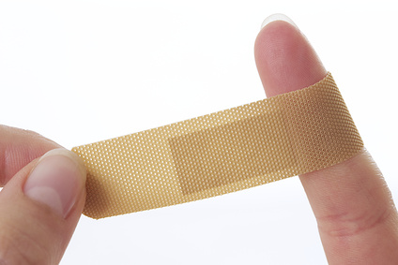

________________ ___________________ __________________ ________________ _______________

________________ ___________________ __________________ ________________ _______________

B. Le Vocabulaire: Put the following in the correct order and in French.

You must rest. _______________________________________________

You must use a bandaid _______________________________________________

You must make a doctor’s appointment _______________________________________________

You must use some ointment ________________________________________________

You must pay attention ________________________________________________

You must visit the doctor. ________________________________________________

C: Le Passé Composé: For each of the following pictures, say what you did.
_______________________________________________________________________
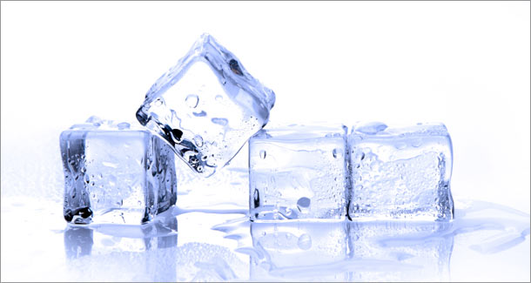

________________________________________________________________________
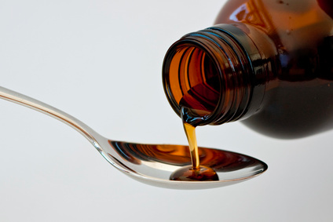

_____________________________________________________________________

________________________________________________________________________
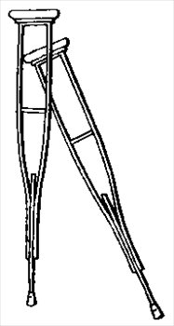

____________________________________________________________________________

________________________________________________________________________
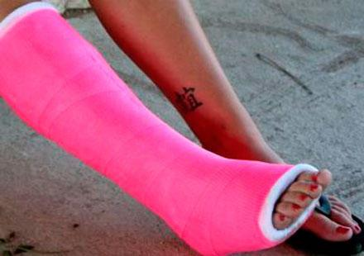

___________________________________________________________________________
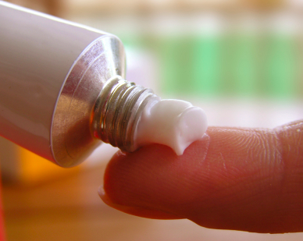

__________________________________________________________________________________________

D. “Qu’est-ce qui s’est passé”: Describe the following accidents.
Sentence 1: What was going on before the accident? (imparfait)
Sentence 2: What happened? (passé composé)
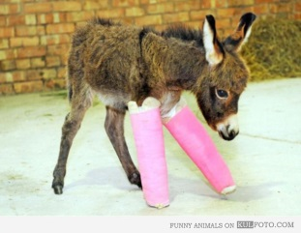
1.______________________________________________________________
2. _____________________________________________________________
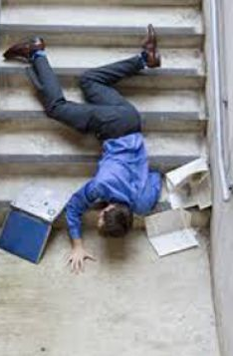

1. _____________________________________________________________

2. _____________________________________________________________

E. Les Passés: Conjugate the following verbes correctly.

avoir mal au nez partir

passé composé je_________________________ nous___________________________

imparfait je_________________________ nous___________________________

se tordre glisser

passé composé ils_________________________ elle___________________________

imparfait ils_________________________ elle___________________________

