FR 1 Devoirs 6.1.4 Nom ___________________________________

A. Speaking: Practice saying where the following people are going, why they are going there and when.
Exemple: I am going to the party to dance on Friday. Parent Initials: ____________
Be sure to mix up the subjects, places and times (using complete sentences) to get lots of practice!
I Monday, Tuesday, Wednesday
YOU 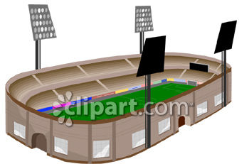 Thursday, Friday, Saturday, Sunday
HE in spring, in summer, in fall, in winter
SHE in january, February, march, april, may,
june
WE july, august, September, October,
YOU GUYS November, December
THEY (m) today, tomorrow, now, later
THEY (f) after school, before school
at _______ o’clock

B. Aller à: Read what the following people like doing. Then write a sentence telling where they are going.

the pool a restaurant the movies the museum the stadium
the beach the library a concert a mall

1. Philippe et Jean-Louis aiment jouer au football. _______________________________________
2. Mlle Bellamy aime l’art moderne. _____________________________________________________
3. Brigitte aime les westerns. ___________________________________________________________
4. Paul et Marc aiment la musique. _____________________________________________________
5. J’aime regarder les magazines français. _______________________________________________
6. Tu aimes diner en ville. ______________________________________________________________
7. Nous aimons nager. _________________________________________________________________
8. Vous aimez le shopping. ____________________________________________________________
C. Le Vocabulaire: According to the pictures, state where the following people are going. Be sure to use complete sentences.

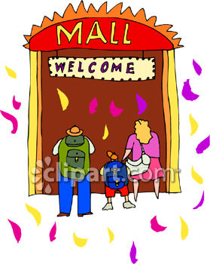 Je _________________________
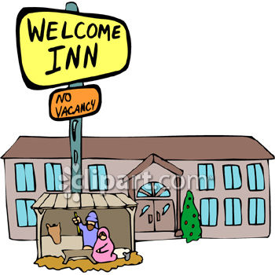 Tu _________________________
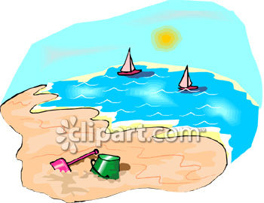 Il ___________________________

Nous ______________________
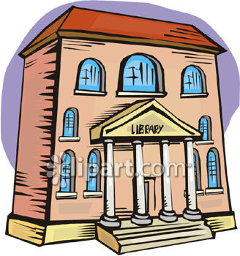 Vous __________________________
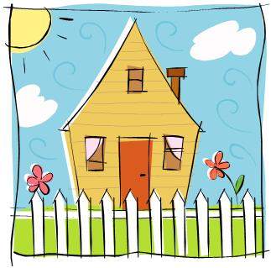 Elles ___________________________

D. À l’hôtel de l’Abbaye

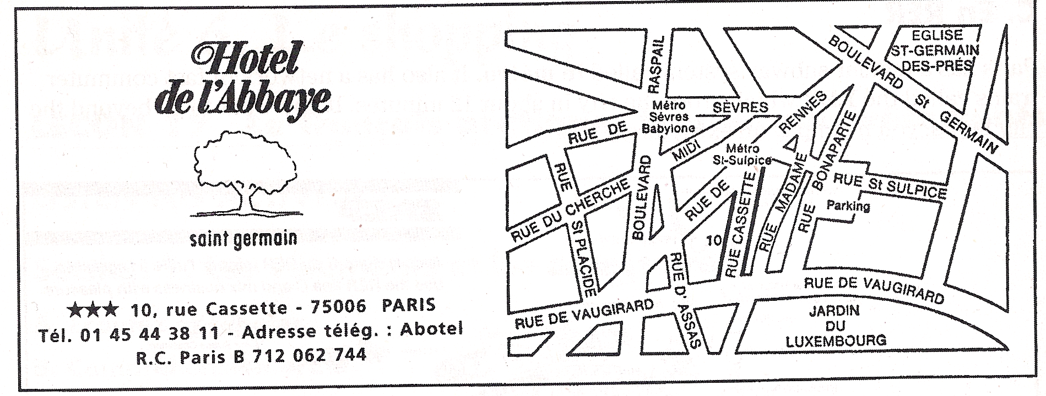

1. You are visiting France with your family and are looking for a hotel.
- What is the name of the hotel shown on the card? _________________________________
- In which city is it located? _____________________________ Which street? ______________
- If you want to make a reservation, what is the phone number? ______________________

2. You have just made your reservation.
- Find the location of the hotel on the map. Mark it with an X.
- You and your family plan to rent a car. Find the nearest parking garage and circle it.

3. Paris also has the metro (subway system). How many stations are shown on the map?_______________
- What is the name of the subway station closest to the hotel? ________________________

4. This map shows one of the oldest churches in Paris. (It was built in the 12th century.) Find the church and draw a star next to it.
- What is its name? ________________________________________________________________
- On which street(s) is it located? ___________________________________________________

5. The map also shows a public garden where many people go jogging
- What is the name of the garden? __________________________________________________
- On which street(s) is it located? ___________________________________________________

