FR 2 Devoirs 5.4.2 Nom ___________________________________

PART I: La pratique orale

A. Imagine that your mom/dad is telling you about all the problems they had on their recent trip. Write down the 5 things they say (in English) and give a suggestion or solution in French. Intl: _______

PROBLÈME SOLUTION/SUGGESTION

__________________________________________ _________________________________________

__________________________________________ _________________________________________

__________________________________________ _________________________________________

__________________________________________ _________________________________________

__________________________________________ _________________________________________

PART II: La pratique écrite

A. According to the following pictures, state what you thing the following people would say:

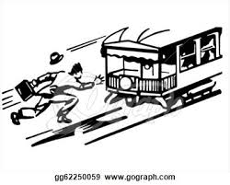

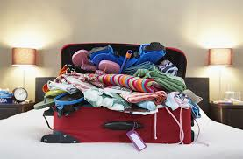

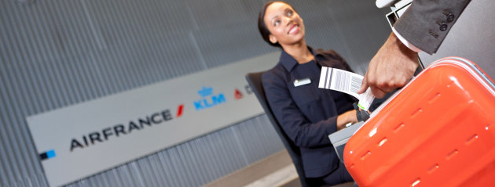

B. Read the following letter from your French correspondant. Fill in the missing words:

Récemment, je ________ ___________ à Genève. J’_____ ________ ___________ en avion. À l’aéroport,

j’_______ ___________________ mes bagages. Après, je __________ ________________ par sécurité. Ils

________ __________________ mon sac. Quand je ________ ______________ à Genève, j’______

__________________ mes bagages. Je _________ ______________ de l’aéroport. J’_______ ___________

un _______________________, une ______________________, et le _________________________.

À bientôt, Claude

C. Now write back to your correspondant and tell him about a recent trip you took by train. Be sure to mention:
- where you went
- how you got there
- include at least 4 things
- 2 things you did while there
- a problem you had during the trip
- how you solved the problem

_________________________________________________________________________________________

_________________________________________________________________________________________

_________________________________________________________________________________________

_________________________________________________________________________________________

_________________________________________________________________________________________

_________________________________________________________________________________________

_________________________________________________________________________________________

_________________________________________________________________________________________

_________________________________________________________________________________________

_________________________________________________________________________________________

_________________________________________________________________________________________

_________________________________________________________________________________________

_________________________________________________________________________________________

_________________________________________________________________________________________

_________________________________________________________________________________________

