FR 2 Devoirs 5.4.1 Nom ___________________________________

PART I: La pratique orale
A. Tell a parent how you travel to the following locations: Intl: _______

B. Explain to your parent the following cultural differences when traveling by train in France: Intl: ________

- where to buy a ticket
- long journeys vs. short journeys
- changing stations
- where to check in
- luggage
- 1st or 2nd class
- overnight trains

PART II: La pratique écrite
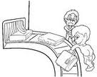
A. The following actions are out of order. Put them in the right order by making complete sentences in the present. Be sure to make the verb match the subjects.
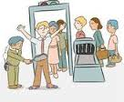
1. Je ___________________________________________

2. Il ___________________________________________

3. Nous_________________________________________

4. Elles_________________________________________
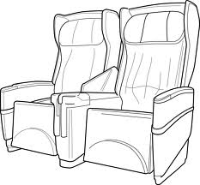

1. Tu ___________________________________________

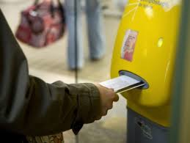
2. Vous _________________________________________
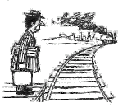

3. Ils____________________________________________

4. Elle___________________________________________

B. Imagine that your cousins Claire and Sophie have just returned from a trip to France and they are showing you pictures of their travels. Write down what you think they would say about each of the following pictures:
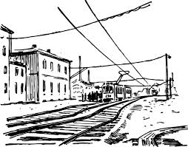
*make sure it is in the past and uses NOUS!

1. ___________________________________________________

______________________________________________________

2. ___________________________________________________

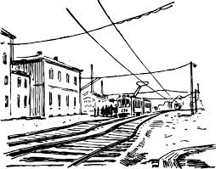
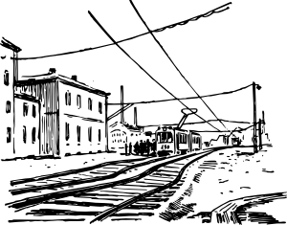
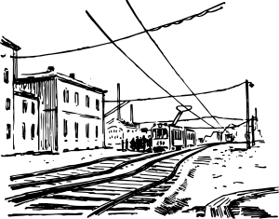
______________________________________________________

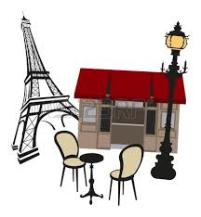

1. ___________________________________________________

______________________________________________________

2. ___________________________________________________

______________________________________________________
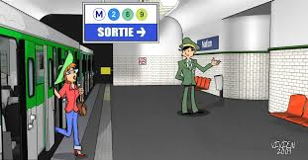

1. _____________________________________________

______________________________________________________

2. _____________________________________________

______________________________________________________

1. ___________________________________________________

______________________________________________________

2. ___________________________________________________

______________________________________________________

