FR 2 Devoirs 5.3.3 Nom ___________________________________

PART I: La pratique orale
A. Memorize the verbs that use être to form the past tense. Pass off with a parent. Intl: ______

aller
arriver
descendre
entrer
rentrer
monter
mourir
naître
partir
passer
rester
retourner
sortir
tomber
venir
revenir
devenir

PART II: La pratique écrite
Say what the following people did at the following times:

Samedi Matin…
- sortir la poubelle

- ranger sa chamber

- passer l’aspirateur

- travailler dans le jardin

- monter les escaliers
Moi: _______________________________________________________

Claire: _____________________________________________________

Paul et Vincent _______________________________________________

Nous _______________________________________________________

Vous _______________________________________________________

Samedi Après-Midi…
- aller au concert

- attendre a une copine

- revenir au café

- retrouver des amis

- choisir un chapeau
Moi: _______________________________________________________

Claire: _____________________________________________________

Paul et Vincent _______________________________________________

Nous _______________________________________________________

Vous _______________________________________________________

Samedi Soir…

Moi: _______________________________________________________
- tomber dans la rue

- finir ses devoirs

- entrer la banque

- préparer le dîner

- arriver au musée

Claire: _____________________________________________________

Paul et Vincent _______________________________________________

Nous _______________________________________________________

Vous _______________________________________________________

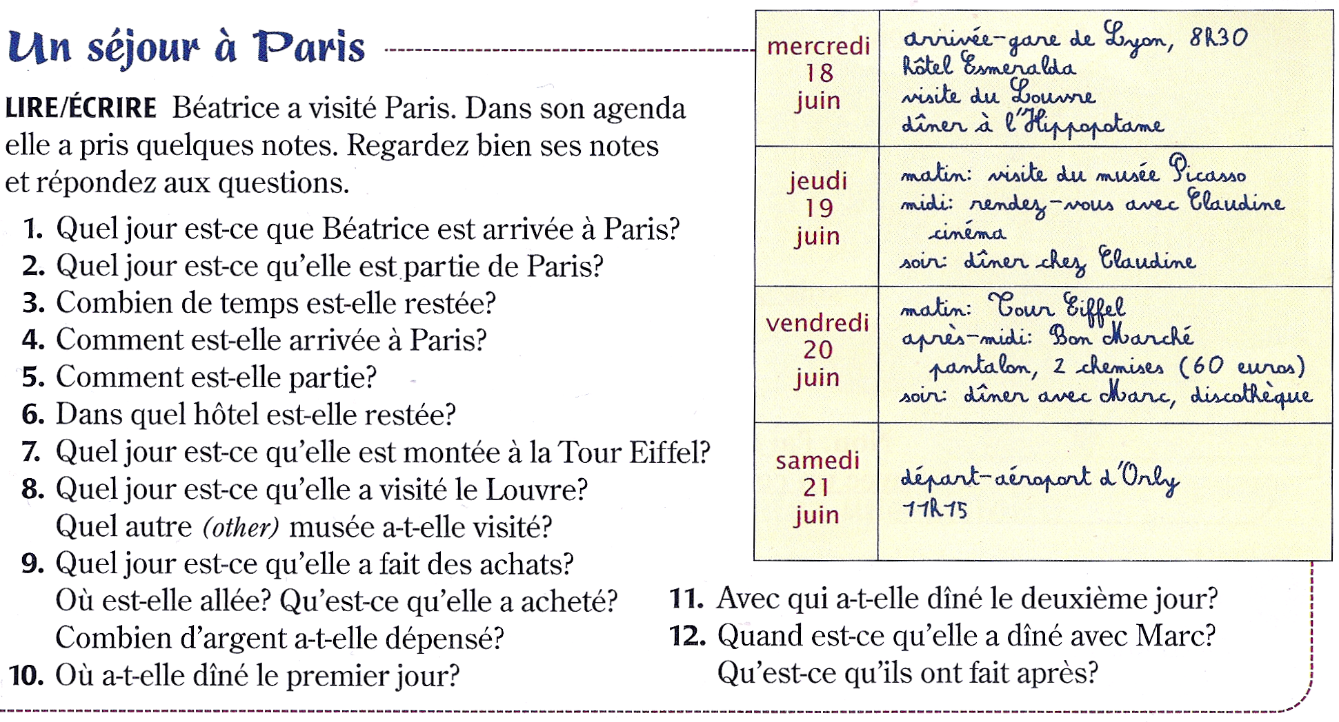

Answer using COMPLETE sentences:

1. _______________________________________________________________________________________

2. _______________________________________________________________________________________

3. _______________________________________________________________________________________

4. _______________________________________________________________________________________

5. _______________________________________________________________________________________

6. _______________________________________________________________________________________

7. _______________________________________________________________________________________

8. _______________________________________________________________________________________

9. _______________________________________________________________________________________

10. ______________________________________________________________________________________

11. ______________________________________________________________________________________

12. ______________________________________________________________________________________

