**FR 2 Devoirs 5.2.1**  Nom ___________________________________

**PART I:** Speaking - Imagine that the map below is your town. Practice telling a parent your opinion about the following places and what you like doing there. Intl: ________

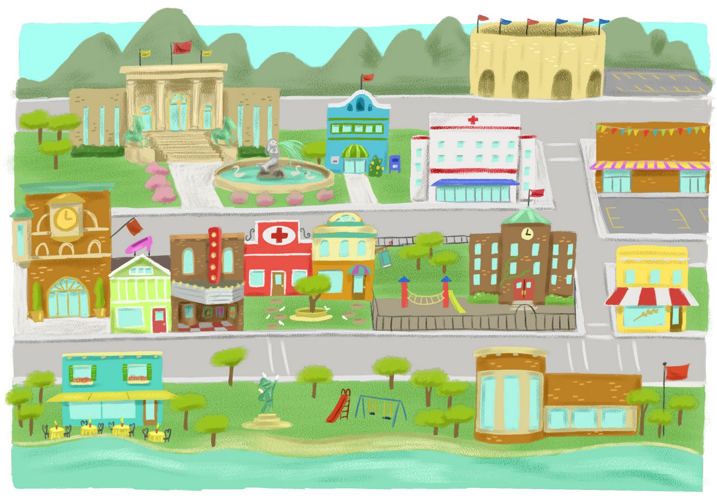

le restaurant

le parc

l’église

le cinéma

l’hôpital

la boutique

le stade

le musée

la bibliothèque

la poste

l’école

le grand

magasin

l’hôtel

les bureaux

la discothèque

**Avenue George V**

**Boulevard St. Michel**

**Rue Saint-Sulpice**

**Rue Monge**

**PART II:** Writing -Now write short directions from point A to point B according to the map above.

|  |  |  |
| --- | --- | --- |
| **POINT A** | **POINT B** | **DIRECTIONS** |
| the parc | the post office |  |
| the museum | the library |  |
| the stadium | the hotel |  |
| the hospital | the restaurant |  |
| the department store | the movies |  |



**PART III:** Où est-ce?

Imagine that you are living in a French town. Someone is asking you for directions. Help the person out, according to the suggestions.

1. –Pardon, où est l’hôtel Beau-Rivage?

- C’est ______________________________

2. –S’il vous plait, où est l’hôpital Velpeau?

- C’est ______________________________

3. –Excusez-moi, où est la bibliothèque municipale?

- C’est ______________________________

4. – Pardon, où sont les toilettes?

 - C’est ______________________________

5. – S’il vous plait, où est la place?

- C’est ______________________________

**PART IV:** Ton Quartier – Name three different places of interest in the area where you live. Describe each one by saying: what it is, where it is, what you do there, compare it to another place.

1. _______________________________________________________________________________________

__________________________________________________________________________________________

2. _______________________________________________________________________________________

__________________________________________________________________________________________

3. _______________________________________________________________________________________

__________________________________________________________________________________________