Leçon 2.3 Devoirs 2 Nom ___________________________________
A. First, write a sentence telling how you feel about the following chores. Then describe it to a parent: Intl: _______

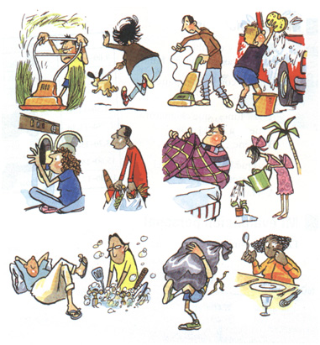
10.
7.
4.
1.

11.
8.
5.
2.

12.
9.
6.
3.

1. ________________________________________ 7. _______________________________________

2. ________________________________________ 8. _______________________________________

3. ________________________________________ 9. _______________________________________

4. ________________________________________ 10. _______________________________________

5. ________________________________________ 11. _______________________________________

6. ________________________________________ 12. _______________________________________
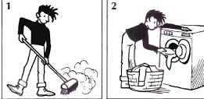
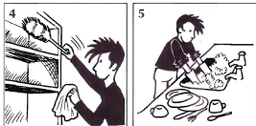

B. Identify where you would do the following things:

1. _________________________________________

2. _________________________________________

3. _________________________________________

4. _________________________________________
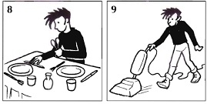
5. _________________________________________

6. _________________________________________

C. Write two sentences describing what you would do in the following locations. (You can use reflexive verbs and chores!)
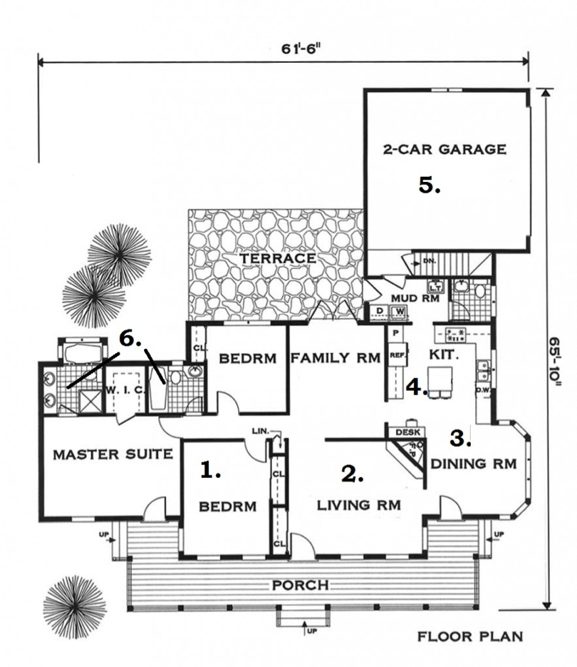
1. __________________________________________

____________________________________________

2. __________________________________________

____________________________________________

3. __________________________________________

____________________________________________

4. __________________________________________

____________________________________________

5. __________________________________________

____________________________________________

6. __________________________________________

____________________________________________

D. La Vie Quotidienne: Write a brief description of the things you do Monday – Friday. Be sure to include reflexive verbs and chores.

__________________________________________________________________________________________

__________________________________________________________________________________________

__________________________________________________________________________________________

__________________________________________________________________________________________

__________________________________________________________________________________________

__________________________________________________________________________________________

__________________________________________________________________________________________

__________________________________________________________________________________________

__________________________________________________________________________________________

__________________________________________________________________________________________

