Leçon 2.3 Devoirs 1 Nom ___________________________________

A. According to the pictures below, write a sentence telling what your chores are. Then teach a parent how to say them.
Intl: ________

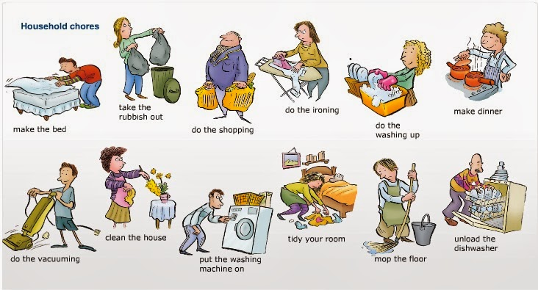

B. For each of the following rooms, use a complete sentence and say what Pierre’s chores are:

1. la cuisine: ___________________________________________________________________________

_________________________________________________________________________________________

2. la chambre:__________________________________________________________________________

_________________________________________________________________________________________

3. la salle de séjour: ____________________________________________________________________

_________________________________________________________________________________________

4. la salle à manger: ___________________________________________________________________

_________________________________________________________________________________________

5. la buanderie: ________________________________________________________________________

_________________________________________________________________________________________

C. In each of the following lists, there are some chores that would not be done in that room. Cross them out! They are the intruder! Then replace them with something that could be done!

1. la salle à manger | mettre la table | débarrasser la table | sortir la poubelle
2. le jardin | faire le lit | tondre la pelouse | désherber
3. le garage | laver la voiture | s’occuper de ses frères | laver la chien
4. la buanderie | faire les poussières | faire le lessive | donner à manger au chat
5. la salle de bains | balayer | nettoyer | cuisiner

D. For each of the following people, say what their chore is:
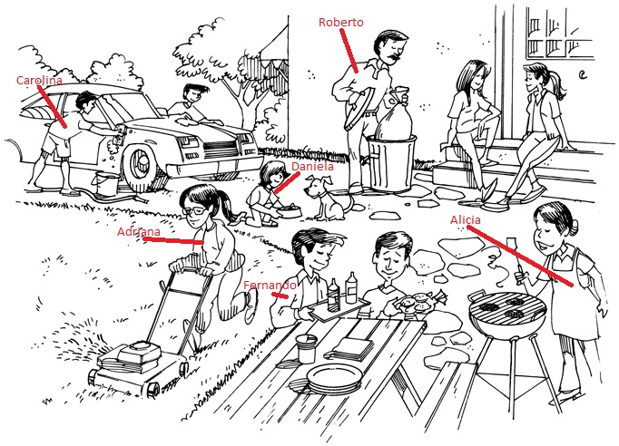

Carolina: ________________________________________________________________________________

Roberto: ________________________________________________________________________________

Daniela: _________________________________________________________________________________

Adriana: _________________________________________________________________________________

Fernando:_______________________________________________________________________________

Alicia: __________________________________________________________________________________

