FR 1 Devoirs 6.2.1 Nom ___________________________________

A. Accepter une invitation: You have been invited to the following places. Accept the invitation and add why you want to go (preference) and what you do there (activities).

1. Est-ce que tu veux aller au concert? 2. Est-ce que tu veux aller à la plage?

____________________________________________ __________________________________________
____________________________________________ __________________________________________
____________________________________________ __________________________________________
____________________________________________ __________________________________________
____________________________________________ __________________________________________
____________________________________________ __________________________________________

B. Refuser une invitation: You have been invited to the following places. Refuse the invitation, add why you can’t go and what you don’t want to do there (activities). Be creative!

1. Est-ce que tu veux aller à la bibliothèque? 2. Est-ce que tu veux aller au restaurant?

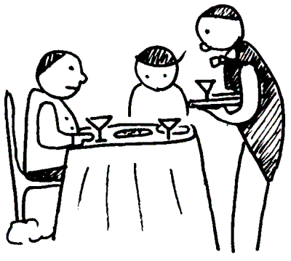

____________________________________________ __________________________________________
____________________________________________ __________________________________________
____________________________________________ __________________________________________
____________________________________________ __________________________________________
____________________________________________ __________________________________________
____________________________________________ __________________________________________
C. Un Dialogue: Write a dialogue between yourself and a friend that follows the outline below. Write as much as possible and be creative!

Personne 1 extend an invitation to go do something with your friend

Personne 2 refuse the invitation and add why you can’t go

Personne 1 extend another invitation to go do something different

Personne 2 accept the invitation, add why and what you do there

Personne 1 _________________________________________________________________________

Personne 2 _________________________________________________________________________

_________________________________________________________________________

Personne 1 _________________________________________________________________________

Personne 2 _________________________________________________________________________

_________________________________________________________________________

_________________________________________________________________________

