FR 1 Devoirs 5.1.5 Nom ___________________________________
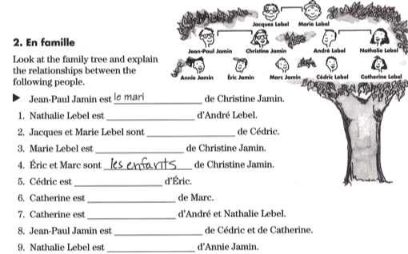
A. Le Vocabulaire:

B. Les Animaux : This is your pet. First fill out the information and then tell a parent about him/her. Be sure to use complete sentences! Parent Initials: ______
Name: ___________________________________________________________
Age: ____________________________________________________________
Personality: ______________________________________________________
Likes: ___________________________________________________________________________________
Dislikes:_________________________________________________________________________________

C. Les Possessifs: Fill in the blanks with the correct possessive adjective:
1. Claire : _______ famille est intéressante.
2. toi : Claire, _______ neveux sont ici.
3. Claire et Jeanne: Marc, Luc et Thierry sont ______ amis.
4. Jeanne et Claire : _______ famille est chouette.
5. moi : Je mange souvent ________ dejeuner.
6. vous : Ah Claire, ________ livre!
7. nous : Jeanne est ________ amie.
8. ils: Claire, Olivier, et Rita? _______ grand-père est adorable.
9. Paul : J'aime la sœur de Claire, mais ______ frère est bizarre.
D. Les Verbes: Translate the following sentences into French.

1. I watch TV _________________________________________________________
2. You eat a lot. _________________________________________________________
3. He cleans his room. _________________________________________________________
4. She has a cat _________________________________________________________
5. We play tennis _________________________________________________________
6. You guys chat _________________________________________________________
7. They (m) text a lot _________________________________________________________
8. They (f) have the watches _________________________________________________________

E. Une Interview: Write down 5 questions you could ask someone about his/her family.
Answer them for a TV family you are familiar with.

1. ___________________________________________________?

- _________________________________________________________________

2. ___________________________________________________?

- _________________________________________________________________

3. ___________________________________________________?

- _________________________________________________________________

4. ___________________________________________________?

- _________________________________________________________________

5. ___________________________________________________?

- ________________________________________________________________

