Leçon 4.3 Devoirs 1 Nom ___________________________________

A. Les Couleurs: List 5 colors in order of preference.

1 _________________________________
2 _________________________________
3 _________________________________
4 _________________________________
5 _________________________________

B. Les Couleurs: What color would you buy the following objects in?

1 un ipod ________________________
2 un portable ________________________
3 une voiture ________________________
4 une mobylette ________________________
5 une bicyclette ________________________

C. Les Couleurs: Write the correct definite article (le, la, l’) before each noun. Then circle if the noun is masculine or feminine. Then circle the correct form of the color that describes each noun.
- ________ tableau M F vert / verte
- ________ raquette M F violet / violette
- ________ calculatrice M F noir / noire
- ________ dictionnaire M F bleu / bleue
- ________ télé M F gris / grise
- ________ téléphone M F blanc / blanche
- ________ montre M F doré / dorée
D. Les Couleurs: Draw, label and color five objects on these desks.
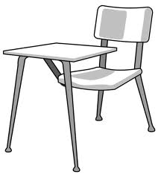
exemple:
un livre
noir
E. La Description: Describe the objects below using the words in parenthesis. Make sure to use the correct form (m/f ) of the adjective and to put it in the correct word order.
modèle: la montre la montre blanche______________(white)

la petite montre ________________(little)

1. la guitare ________________________________ (gray)

________________________________ (bad)

2. l’Ipod ________________________________ (small)

________________________________ (silver)

3. l’écran ________________________________ (big)

________________________________ (white)

4. l’auto ________________________________ (red)

________________________________ (pretty)

