FR 2 Leçon 4.2 Devoirs 1 Nom ___________________________________

PART I: La pratique orale:
A. Practice telling a parent what you did last weekend by first writing a sentence and then telling them out loud! Intl: _______
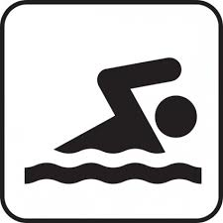
1. _______________________ 2. __________________________

__________________________ _____________________________

3. _______________________ 4. ___________________________

__________________________ _____________________________
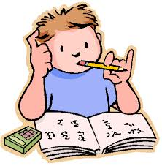
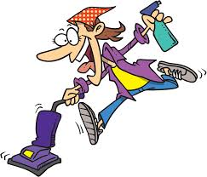
5. _______________________ 6. ___________________________

__________________________ _____________________________

PART II: La pratique écrite
A. Fill in the blanks with the appropriate words:

7. Qu’est-ce que tu ______ ____________ le week-end dernier?

J’_______ _______________ un film.

8. Quel film est-ce que tu ______ ______________?

J’_______ _______________ The Hobbit.

9. Qui ________________ l’acteur?

L’acteur ____________________ Martin Freeman.

10. Quel rôle est-ce qu’il ________ ________________?

Il ________ _______________ le rôle de Bilbo.

11. Qu’est-ce qu’il ________ _________________?

Il ________ ______________ un pantalon marron.

12. Quel genre de film ______________- _________?

_____________________ un film d’aventure.

13. Comment _____________________ le film?

_____________________ incroyable!

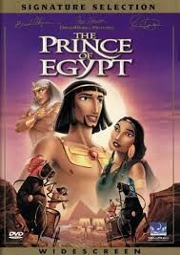
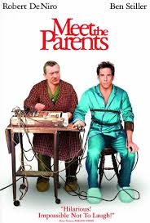
B. Compare the two things below by saying how they were

________________________________________________

________________________________________________

Pourquoi?

________________________________________________

________________________________________________

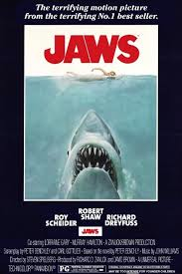
________________________________________________

________________________________________________

Pourquoi?

________________________________________________

________________________________________________

C. Write a note telling your mom that you did all of your tâches ménagères over the weekend.

_____________________________________________________
- ranger mes livres
- ranger ma chambre
- nettoyer le garage
- finir mes devoirs
- laver mes vêtements
- rendre visite à ma grand-mère

_____________________________________________________

_____________________________________________________

_____________________________________________________

_____________________________________________________

_____________________________________________________

D. Say some things you did at each of the following times. (NOT where you went.) Pay attention to the subject!

1. Hier avant le dîner j’... _____________________________________________________________________________________

2. Après le dîner, j’... _____________________________________________________________________________________

3. Ce matin, pendant la classe, les élèves... _____________________________________________________________________________________

4. À la maison samedi dernier, j’... _____________________________________________________________________________________

5. Chez mon copain, nous... _____________________________________________________________________________________

6. Pour ma fête d’anniversaire, j’... _____________________________________________________________________________________

7. Pour la fête de Thanksgiving, nous... _____________________________________________________________________________________

8. Pendant les vacanes, mes amis et moi... ________________________________________________________________________________________

