FR 2 Devoirs 6.1.2 Nom ___________________________________

A. La pratique orale: Make a list of 15 body parts and then teach them to a parent.
Intl: ______

__________________________ ______________________________ ________________________

__________________________ ______________________________ ________________________

__________________________ ______________________________ ________________________

__________________________ ______________________________ ________________________

__________________________ ______________________________ ________________________

B. J'ai mal... Using the pictures write a short sentence describing what each person has and a second sentence describing what hurts.
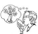
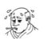
Ex: Elle éternue. Elle a des allergies.

1. __________________________________________________________________________
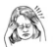
2. __________________________________________________________________________
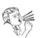
3. __________________________________________________________________________
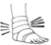
4. __________________________________________________________________________
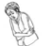
5. __________________________________________________________________________
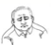
6. __________________________________________________________________________

C. Complete the following sentences with the verb aller to say where the following people went.

1. Moi et mes frères _____________________________________________________ au parc

2. Nicole _____________________________________________________ à la banque

3. Je _____________________________________________________ à la campagne.

4. Paul et Jean _____________________________________________________ à l’hôtel.

5. Toi et tes amis _____________________________________________________ au magasin.

6. Claire et Sophie _____________________________________________________ au lac.

D. Complete the sentences describing what hurts, circling the correct article and match
with the cause.

1. J’ai mal au/à la _______________________ parce que _____ a. j’ai glissé

2. J’ai mal au/à la ________________________ parce que _____ b. je suis tombé(e)

3. J’ai mal au/à la _______________________ parce que _____ c. je me suis cassé le bras

4. J’ai mal au/à la _______________________ parce que _____ d. j’ai attrapé un rhume

5. J’ai mal au/à la _______________________ parce que _____ e. j’ai des allergies

E. Describe what the following people did NOT do last weekend.

1. (acheter) Mélanie ___________________________________________ des fruits

2. (faire) Hélène et Julien ___________________________________________ une promenade.

3. (voir) Nous ___________________________________________ des lions dans le parc!

4. (avoir) Mon frère ___________________________________________ un accident.

5. (prendre) Vous ___________________________________________ un bon repas au café.

F. By looking at the pictures of the following people. Come up with a sequence of THREE things that happened to get them to what you see.
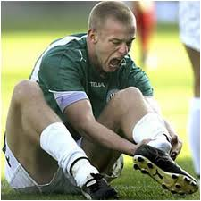
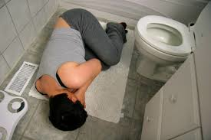
Example: He went upstairs to clean the bathroom. He cleaned the floor. He slipped.
_____________________________________________________

____________________________________________________













