FR 2 Devoirs 6.1.1 Nom ___________________________________

A. La pratique orale: Explain to a parent how to talk about where things “hurt” in French. Then use the following pictures to say out loud to your parent where this person hurts! Intl: ____________

B. La pratique écrite : Comment se sentent-ils?
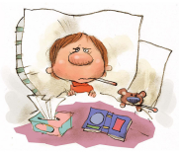

__________________________________ ____________________________________
_________________________________ ____________________________________
_________________________________ ____________________________________
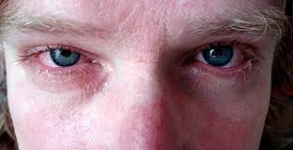
_________________________________ __________________________________

__________________________________ __________________________________

C. Fill in the missing words:

1. J’ai mal ______ dents.

2. Il a mal ______ nez.

3. Nous avons mal ______ lèvres.

4. Elle a mal ______ langue.

5. Tu as mal ______ oreille

6. J’ai mal ______ bras.

7. Il a mal ______ cheville.

8. Ils ont mal ______ doigts

9. Vous avez mal ______ poignet.

10. Tu as mal ______ gorge.

D. Circle the correct word:

1. J’ai mal aux… ventre genou coude dos dents

2. Tu as mal au… nez bouche lèvre langue tête

3. Il a mal à la… oeil front jambe oreille estomac

4. Elle a mal à l’… épaule bras main pied genou

E. For the following situations, write a sentence explaining how you might feel afterward.

1. A car accident: _______________________________________________________________________

2. Falling out of a tree house ___________________________________________________________

3. Being tackled in football _____________________________________________________________

4. Slamming your hand in the door _____________________________________________________

5. Eating a hard piece of candy _________________________________________________________

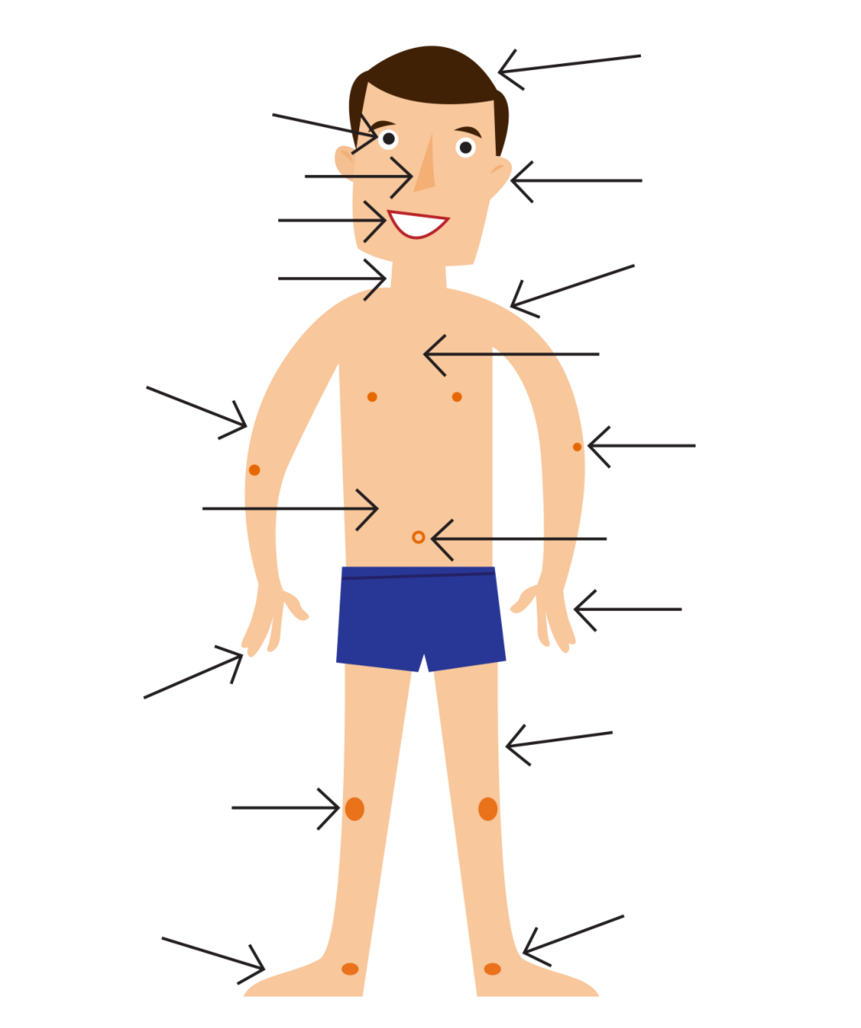
E. Label the following parts of the body! Can you figure out “belly button?”

