Leçon 1.3 Devoirs 1 Nom ___________________________________

A. L’Heure: Write out the time, in French, you do the following activities:

exemple: shower Il est six heures dix. (6h10)

1. get dressed _____________________________
2. eat breakfast _____________________________
4. go to school _____________________________
5. eat lunch _____________________________
6. start French class _____________________________
7. do homework _____________________________
8. watch TV _____________________________
9. talk on the phone _____________________________
10. go to bed _____________________________

B. L’Heure: Write the following times in French.
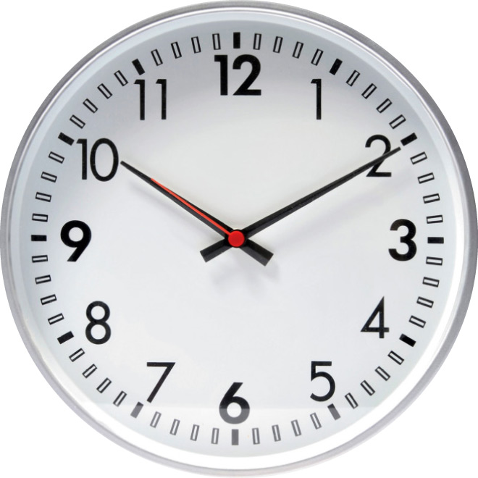
1 _______________________________________
2 _______________________________________
3 _______________________________________
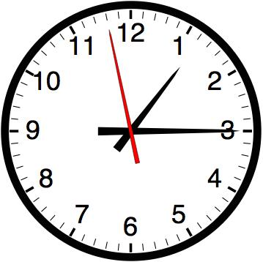
4 _______________________________________
5 _______________________________________
6 _______________________________________
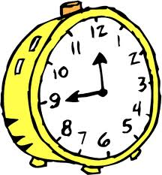
7 _______________________________________
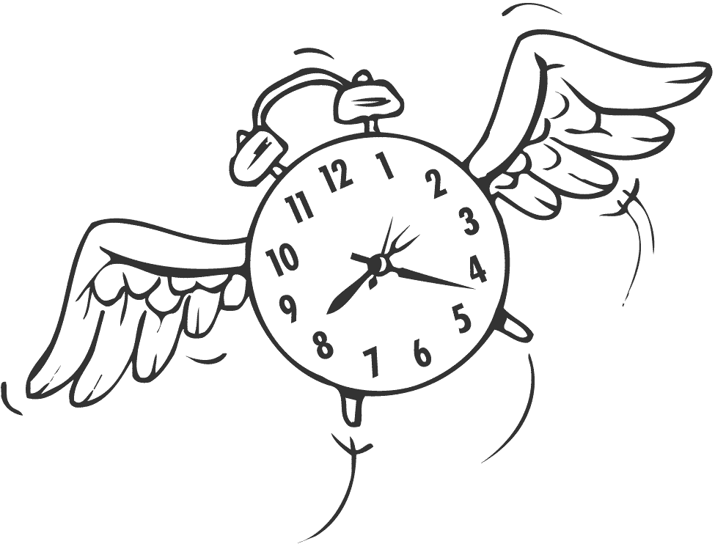

C. Une Introduction: Write out, in French, a short but complete conversation between two students getting to know each other. Include elements from each vocab list.

Student 1 ______________________________________________________________
Student 2 ______________________________________________________________
Student 1 ______________________________________________________________
Student 2 ______________________________________________________________
Student 1 ______________________________________________________________
Student 2 ______________________________________________________________
Student 1 ______________________________________________________________
Student 2 ______________________________________________________________
Student 1 ______________________________________________________________
Student 2 ______________________________________________________________
Student 1 ______________________________________________________________
Student 2 ______________________________________________________________
Student 1 ______________________________________________________________
Student 2 ______________________________________________________________

