Leçon 2.2 Devoirs 4 Nom ___________________________________

A. Le Vocabulaire: For each of the following pictures, write a sentence telling what the place is and something about it that is true for your house.
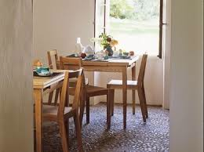
_____________________________________________
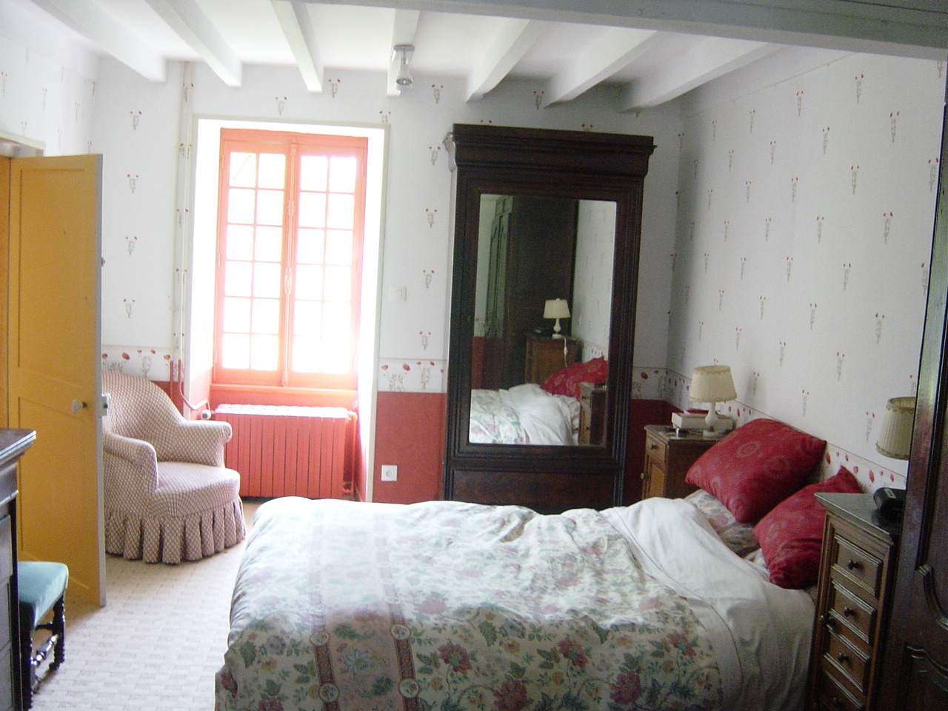
_____________________________________________

_____________________________________________
______________________________________________
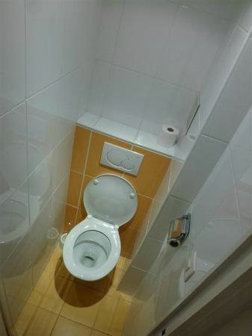
_____________________________________________
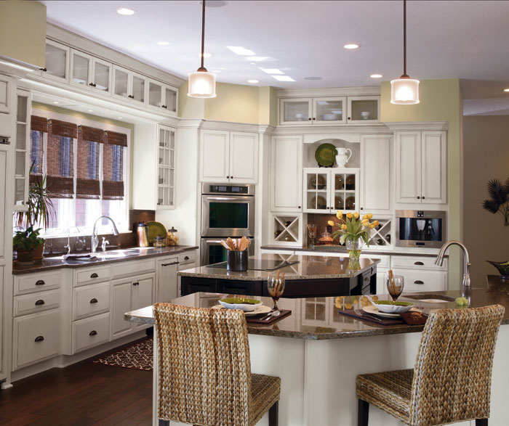
_____________________________________________

_____________________________________________
______________________________________________
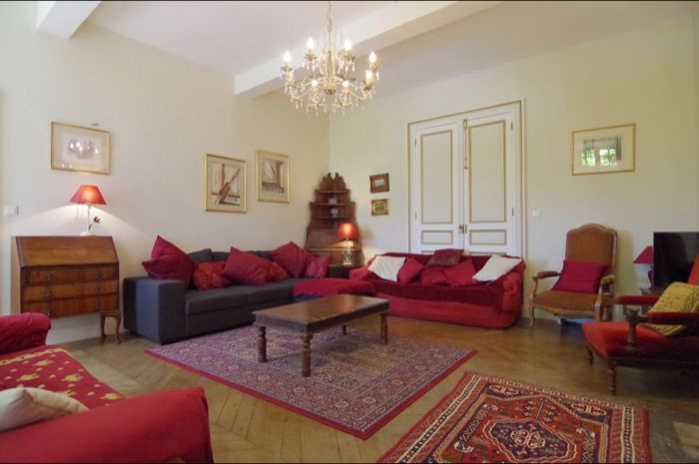
_____________________________________________
_____________________________________________
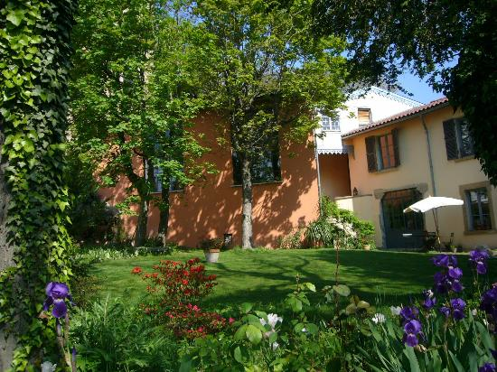
_____________________________________________
______________________________________________

B. A l’ecrit: Complete the following sentences:

1. J’habite dans________________________________________________________________________

2. Ma maison est _______________________________________________________________________

3. Les couloirs sont _____________________________________________________________________

4. La cuisine est peinte (painted) en _____________________________________________________

5. Ma chambre est peinte en ____________________________________________________________

6. Dans le salon, il y a __________________________________________________________________

7. En général, nous dînons dans ________________________________________________________

8. Ma maison a ________________________________________________________________________

C. Où sont-ils? From the description of what the following people are doing, say where they are using a complete sentence:

1. Nous dînons _____________________________________________

2. Je m’habille _____________________________________________

3. Tu regardes la télé _____________________________________________

4. Vous vous se douchez _____________________________________________

5. Antoine et Juliette jouent au foot _____________________________________________

6. J’étudie le français _____________________________________________

7. Elle se maquille _____________________________________________

8. M. Martin prépare le dîner _____________________________________________

D. Ma Maison et la Routine Quotidienne: Write a paragraph that combines the following elements from lessons 1 and 2 to describe your daily routine.

- reflexive verbs
- getting ready objects
- rooms of the house
- furniture
- prepositions

______________________________________________________________________________________________________________________________________________________________________________________________________________________________________________________________________________
____________________________________________________________________________________________________________________________________________________________________________________
____________________________________________________________________________________________________________________________________________________________________________________
____________________________________________________________________________________________________________________________________________________________________________________
____________________________________________________________________________________________________________________________________________________________________________________
__________________________________________________________________________________________

