FR 2: Leçon 5.1 Devoirs 2 Nom_________________________

A. Speaking – Où faut-il aller? Tell a parent where you need to go in order to do the following things.
Example: Il faut aller… pour … Parent Initial: ____________

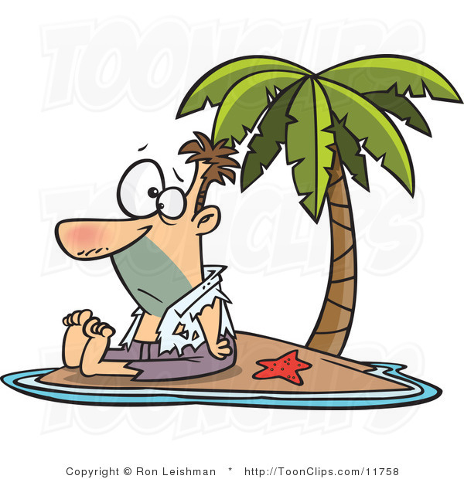
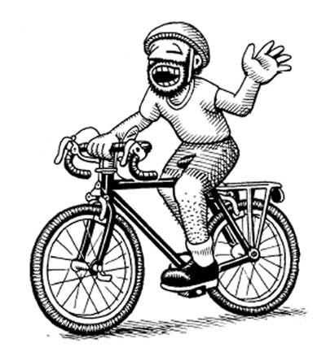

B. Speaking – Tell a parent your opinions about the following places. Be sure to compare the two and use complete sentences! Parent Initial: ____________
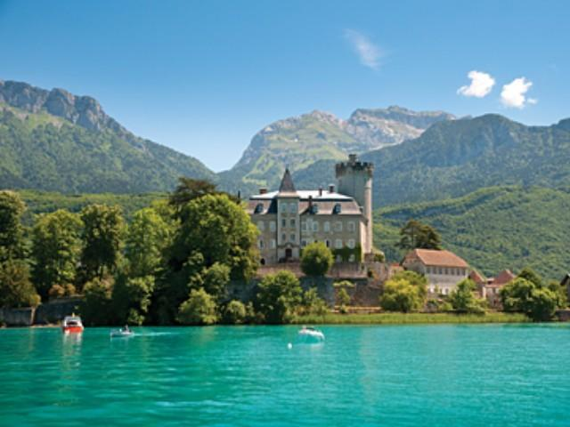
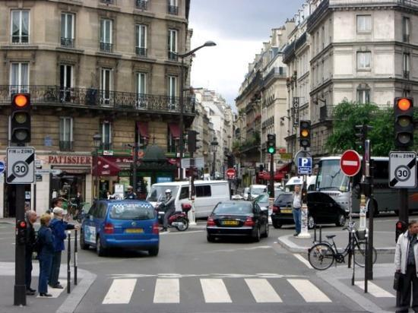
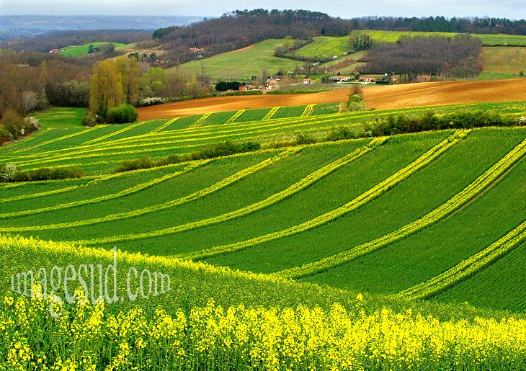
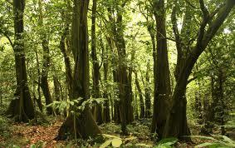

C. Writing – Below are two places and an adjective. Use the comparative to create a sentence that compares the two places.

1. le cascade / la rivière rapide ______________________________________________________

2. le lac / la piscine grand(e) ______________________________________________________

3. la forêt / le parc amusant(e) ______________________________________________________

4. la discothèque / le musée studieux (se) ______________________________________________________

5. les bureaux / les cinémas ennuyeux(se) ______________________________________________________

D. Writing – Imagine that you are writing a report comparing your city to one of the cities listed below. Do a little research online about the city you choose and then write at least 10 sentences comparing the two.

Montréal Genève Abidjan Port-au-Prince

__________________________________________________________________________________________

__________________________________________________________________________________________

__________________________________________________________________________________________

__________________________________________________________________________________________

__________________________________________________________________________________________

__________________________________________________________________________________________

__________________________________________________________________________________________

__________________________________________________________________________________________

__________________________________________________________________________________________

__________________________________________________________________________________________

