FR 2: Leçon 5.1 Devoirs 3 Nom ____________________________________

A. Write a sentence comparing the following places. Then describe these places out loud to a parent.
Parent Initial: ____________
_____________________________________________________

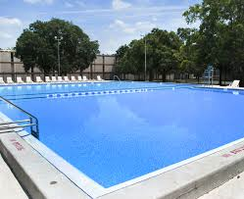
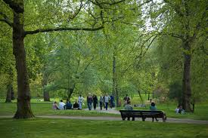
_________________________________________________________________________________________

__________________________________________________________________________________________

_______________________________________________________________________________

B. Imagine your friend is visiting Orem for the first time. Fill in the blank to explain where he needs to go to do certain things:

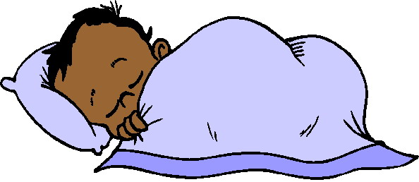
1. Pour ____________________,il faut aller ________________________
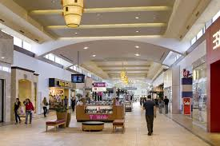
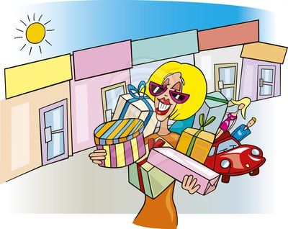

2. Pour ____________________,il faut aller ________________________
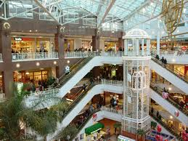
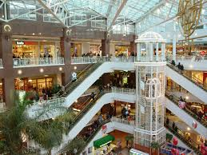
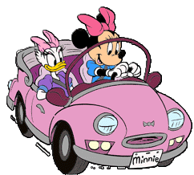
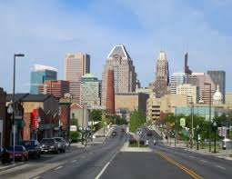
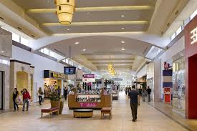
3. Pour ____________________,il faut aller ________________________

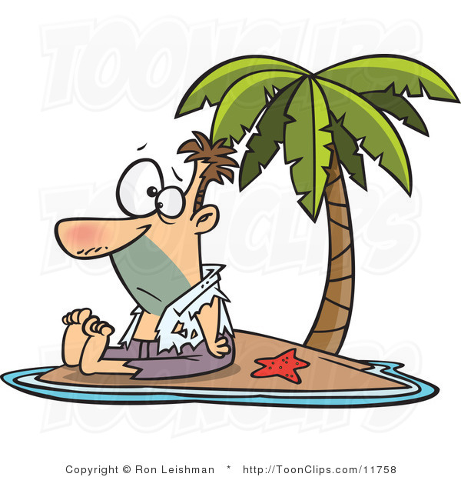
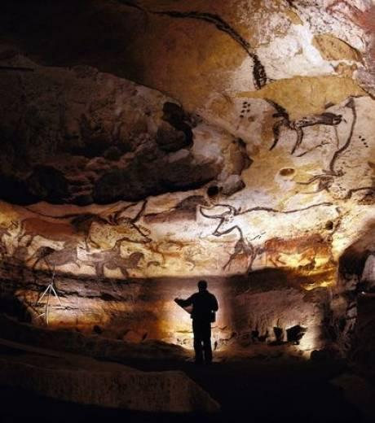
4. Pour ____________________,il faut aller ______________________

5. Pour ____________________,il faut aller _______________________
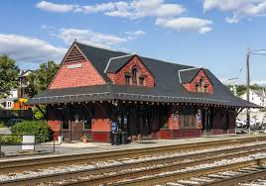

C. Between the things listed below, write a sentence saying which you prefer and why.

Airport Train Station

________________________________________________________________

Large Store Boutique
________________________________________________________________

Park Museum

________________________________________________________________

Forest Downtown
________________________________________________________________

D. Compare your hometown to one of the towns below. Be sure to include as much detail as possible!

New York City Provo LA Hurricane

__________________________________________________________________________________________

__________________________________________________________________________________________

__________________________________________________________________________________________

__________________________________________________________________________________________

__________________________________________________________________________________________

__________________________________________________________________________________________

__________________________________________________________________________________________

__________________________________________________________________________________________

__________________________________________________________________________________________

__________________________________________________________________________________________

__________________________________________________________________________________________

__________________________________________________________________________________________

