**FR 2: Leçon 5.1 Devoirs 1** Nom ______________________________

**A.** Speaking – Briefly describe your town to a parent. Be sure to mention the following places and 1 thing you like to do at each place. Use complete sentences! Initial: ______

**PLACE THING YOU LIKE TO DO**

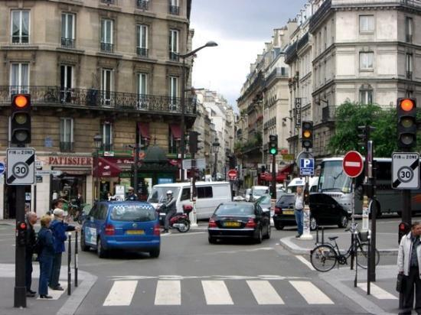

________________________________________________________________

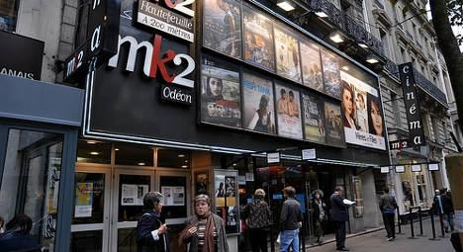

________________________________________________________________

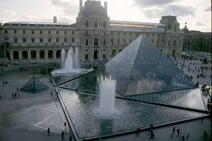

________________________________________________________________

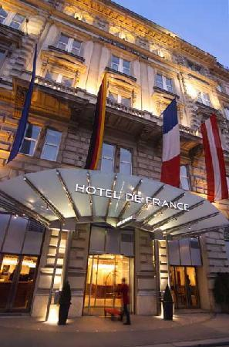

________________________________________________________________

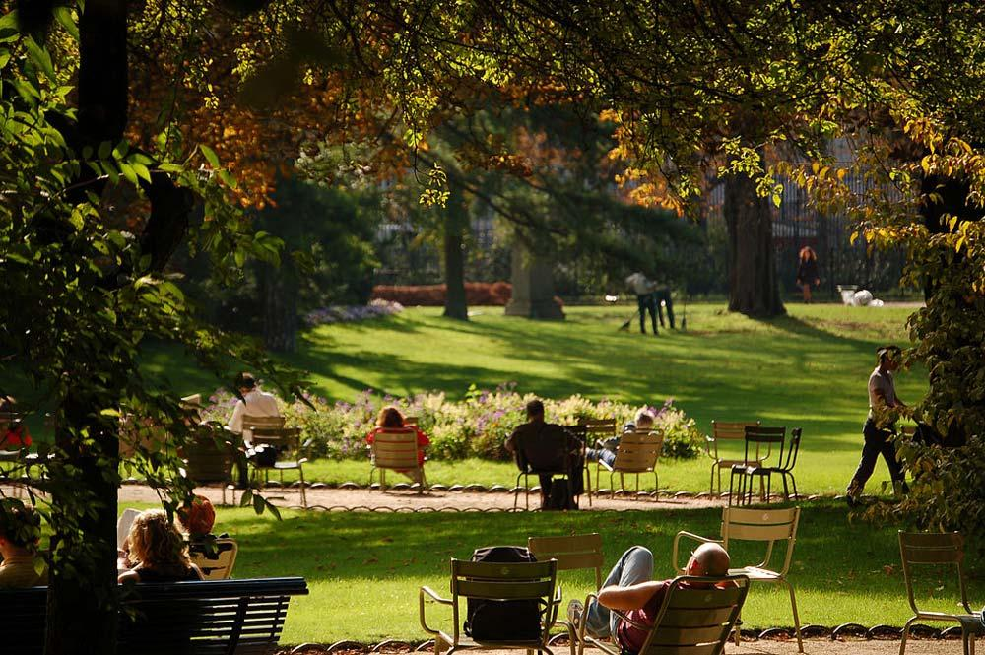

________________________________________________________________

**B.** Writing – Between the two things below, state which one you prefer and why. Be sure to use complete sentences.

Downtown Country ________________________________________________________________

________________________________________________________________

Lake River ________________________________________________________________

________________________________________________________________

Movies Museum ________________________________________________________________

________________________________________________________________

Bank Post Office ________________________________________________________________

________________________________________________________________

Airport Bus Station ________________________________________________________________

________________________________________________________________

Department Boutique ________________________________________________________________

Store

________________________________________________________________

Park Cave ________________________________________________________________

 ________________________________________________________________

**D.** Writing – You are writing your pen pal a letter about your town and why he/she should come visit you. Be sure to describe your town and mention 5 places you like to go and why you go there.

_________________________________________________________________________________________

_________________________________________________________________________________________

_________________________________________________________________________________________

_________________________________________________________________________________________

_________________________________________________________________________________________

_________________________________________________________________________________________

_________________________________________________________________________________________



_________________________________________________________________________________________

_________________________________________________________________________________________